**Chip & Micky Immune Products** – 9 Apr 2019

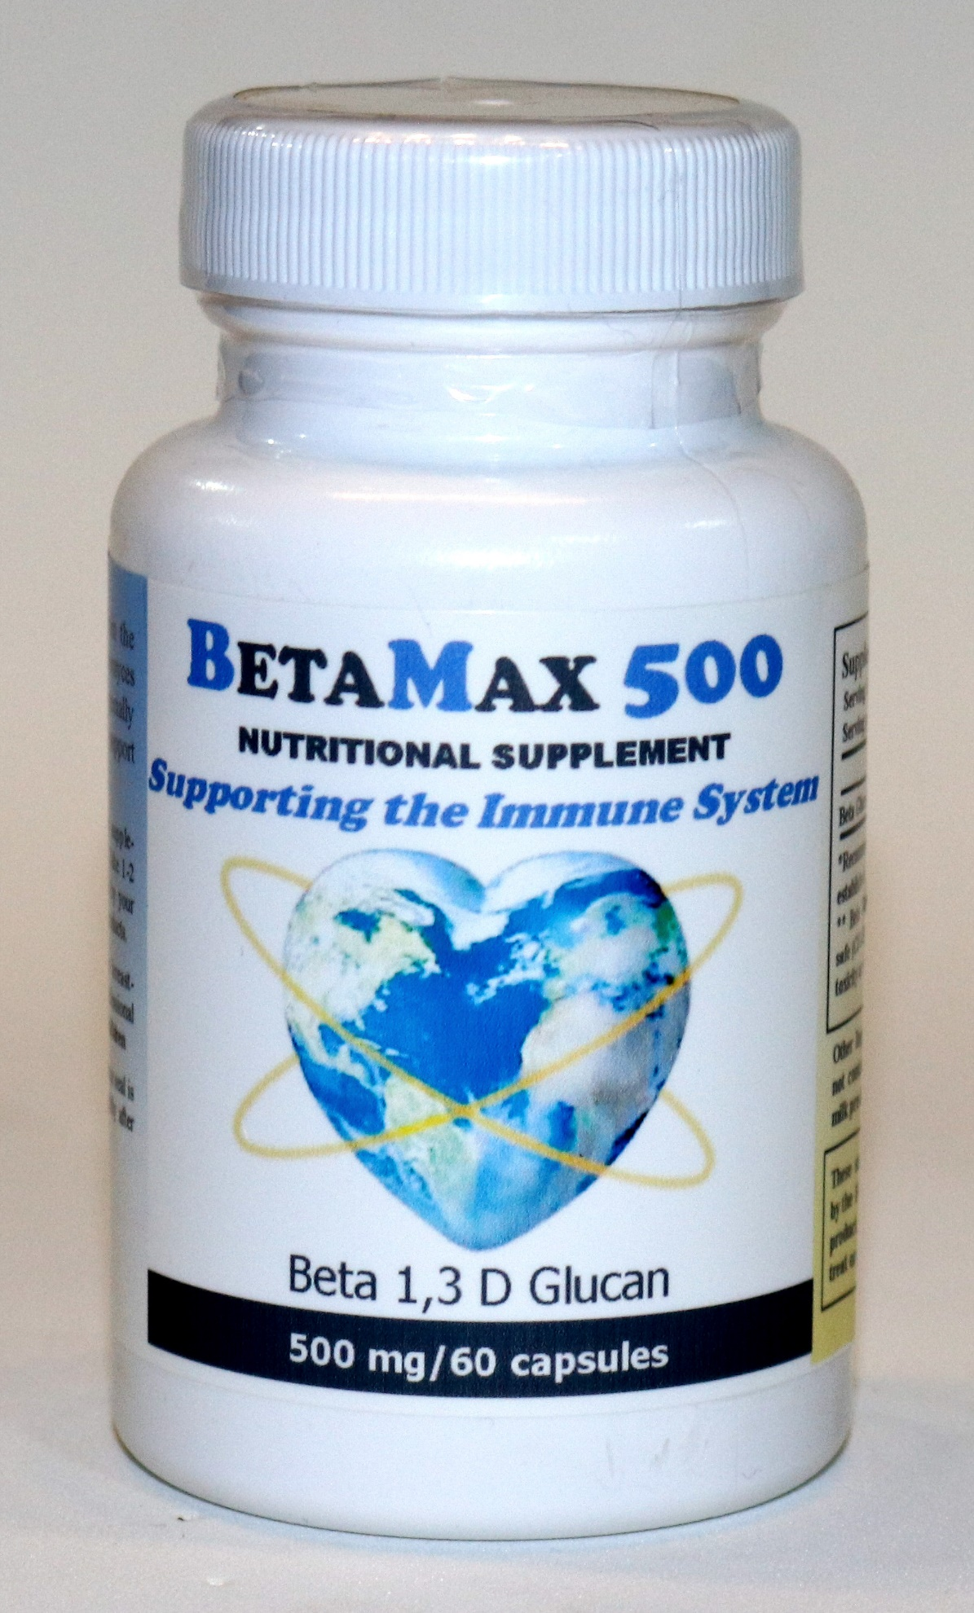

1. BetaMax 500 : Beta 1,3 D Glucan

IMG_1222.JPG

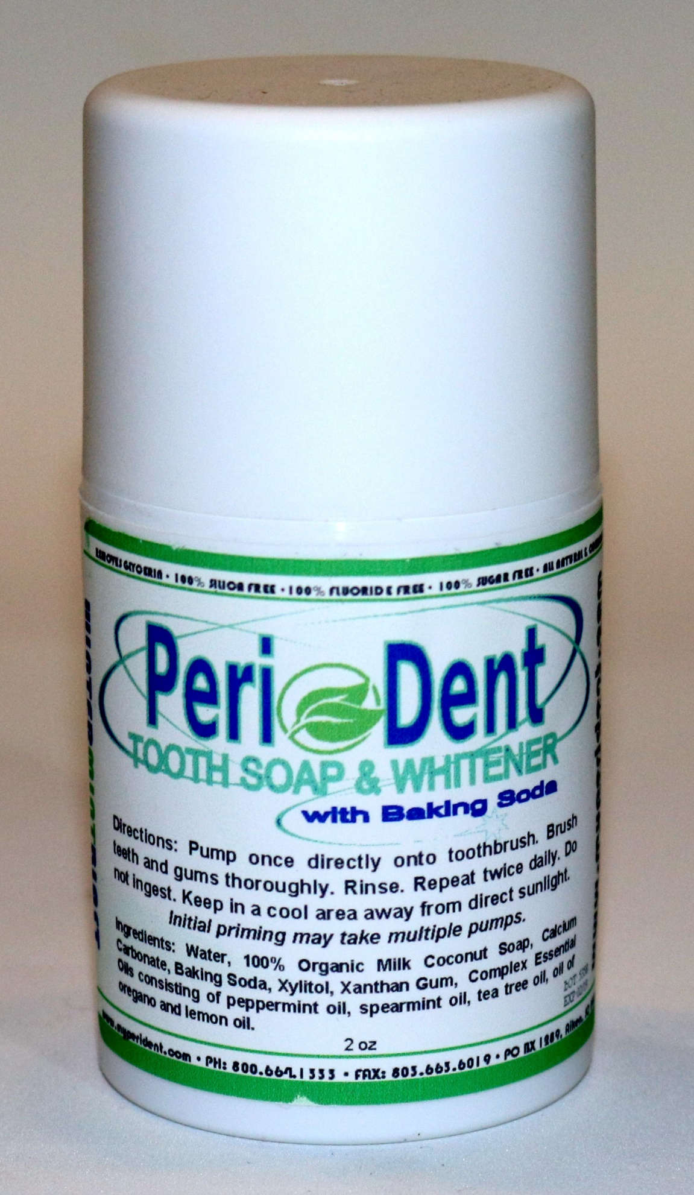

1. PeriDent Tooth Soap & Whitener (with Baking Soda)

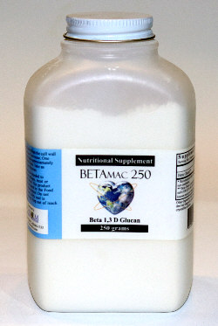

1. BetaMac 250 : Beta 1,3 D Glucan -- [ IMG_1228.JPG ]

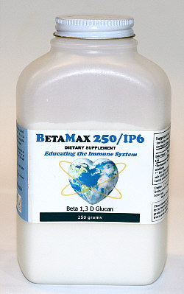

1. BetaMax 250 / IP6 : 250 gr. / Beta 1, 3 D Glucan

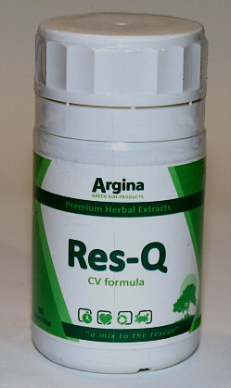

1. Res-Q / CV formula

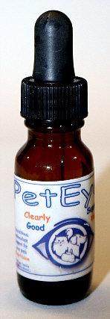

1. Pet Eye

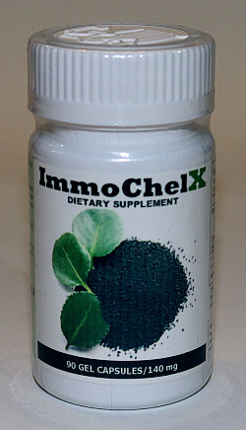

1. ImmoChelX – 90 Gel Capsules / 140 mg

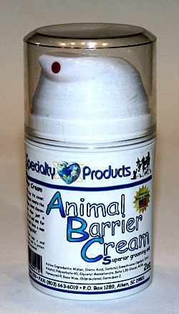

1. Animal Barrier Cream / 2 oz

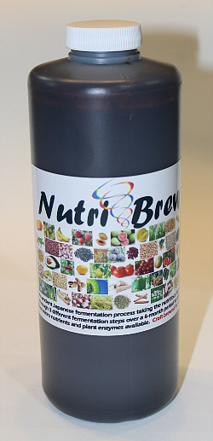

1. Nutri Brew