Re-check in January through March, 2015:
a New Phase of the Story.
Remember the story on page 1 about the ultrasound examination
on January 29, 2014. One of the findings was a tiny spot behind the nipple, which was presumed to be the beginning of a small tumor. During the
June-through-August applications of salve, I never put any on the nipple,
and even though you have seen examples where salve spreads
through the tissues, there were apparently a few remaining cancer cells
inside the nipple that were not reached by the salve.
Although I canot prove that the second tumor spot
(right beside the first one) and the small tumor spot behind the nipple
were a result of cancer cells being spread by a biopsy needle,
I have little reason to believe anything else since these two spots
were directly in the path of the biopsy needle, and were not there
at the time of the original ultrasound-guided biopsy,
on November 1, 2013, a little less than three months earlier.
Since we are looking at a small area, I have used arrows and circles
in some of the pictures to show where to focus your attention.
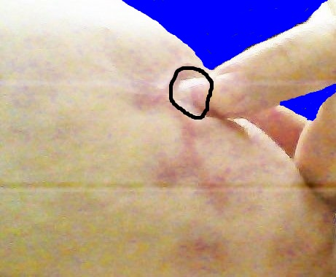 |  |  |  |  |  |  |  |  |  |  | 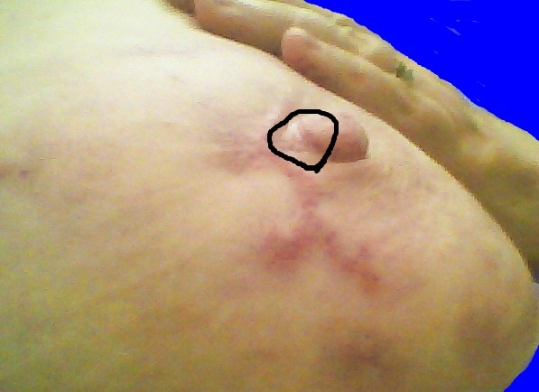
January 7, 2015, 21:34:20. A spot at the base of the nipple looks slightly enlarged, and feels hard. The skin color there looks a little more white than the surrounding area. |  |  |  |  |  |  |  |  |  |  |  |  |  |  |  |  |  |  |  |  |  |  |  | January 11, 18:27:00. Four days later, the hard spot is still there, and seems to be standing out more.
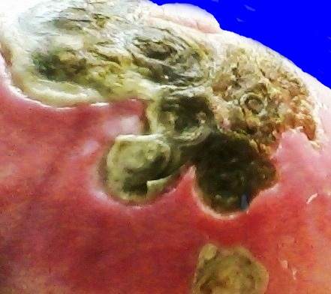 |  |  | 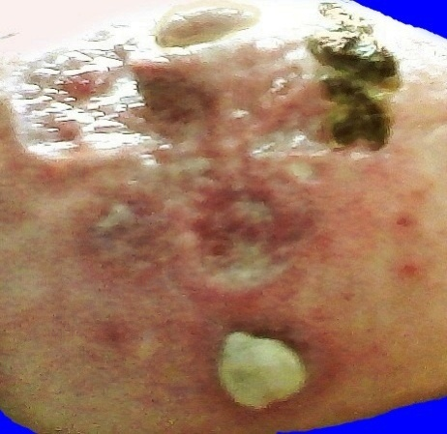 |  |  |  |  |  |  |  |  |  |  |  |  |  |  |  |  |  |  |  |  |  | 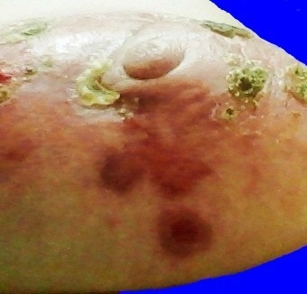
Flashback to July 5 |  |  | Flashback to July 15 |  |  |  |  |  |  |  |  |  |  |  |  |  |  |  |  |  |  |  |  |  | Flashback to July 29
The hyperpigmentation and scar tissue in the pictures in the top row of this page are reminiscent of first the eschar pattern on the left above, then the decavitations in the middle, and finally, the hyperpigmentation on the right. The difference is, now the reddish purple marks have become much smaller, and have blurred edges where they are fading back toward the original skin color.
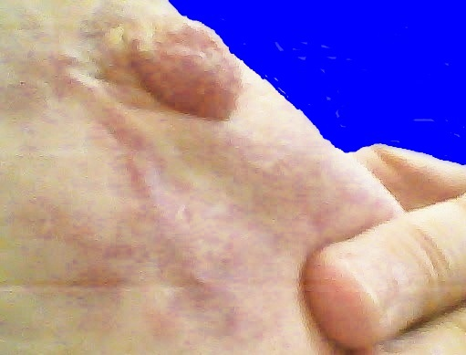 |  |  |  |  |  |  |  |  |  |  |  |  |  | 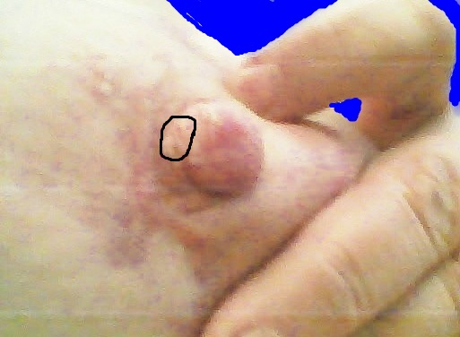
January 14, 10:19:09 |  |  |  |  |  |  |  |  |  |  |  |  |  | January 14, 10:19:40.
I applied salve on January 13, and on the morning of the 14th, I was having the beginning of an escharotic reaction.
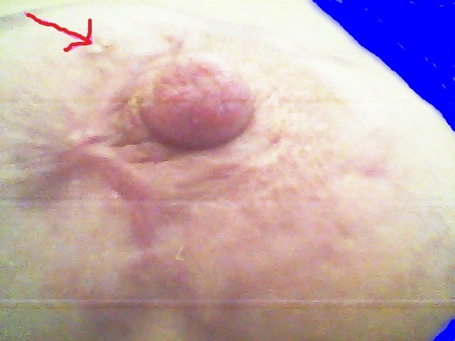 |  |  |  |  |  |  |  |  |  |  |  |  |  |  | 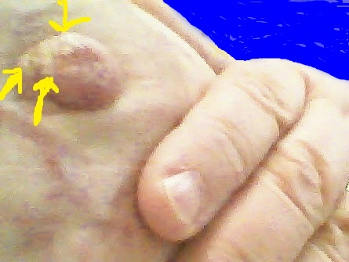
January 14, 10:21:09 |  |  |  |  |  |  |  |  |  |  |  |  |  |  | January 14, 10:19:28
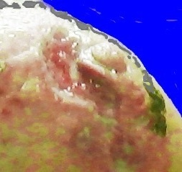 |  | 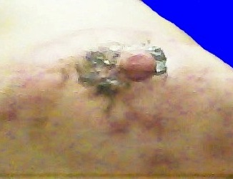 |  |  |  |  |  |  |  |  |  |  |  |  |  |  |  |  |  |  |  |  |  |  | 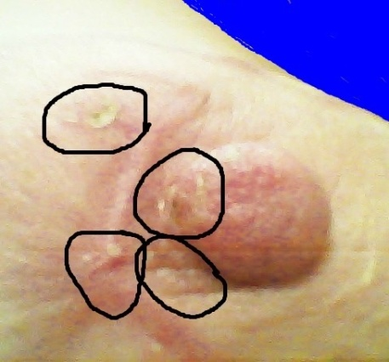
Flashback to July 15. The obtuse angle of scar tissue in most of the pictures on this page is reminiscent of the angle beside the nipple where the main eschar mass had just ejected. |  |  |  |  |  | January 15, 01; 48:34. I applied salve mixed with coconut oil on both sides of the nipple before going to bed. |  |  |  |  |  |  |  |  |  |  |  |  |  |  |  |  |  |  | Jan. 15, 17:38:04. 16 hours later small eschars are popping out, both on the side of the nipple, and a little further out.
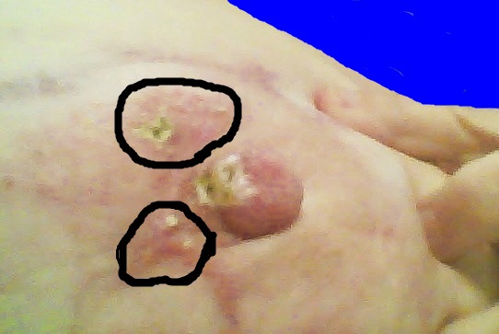 |  |  |  |  |  |  |  |  |  |  |  |  |  |  |  |  |  |  |  |  |  | 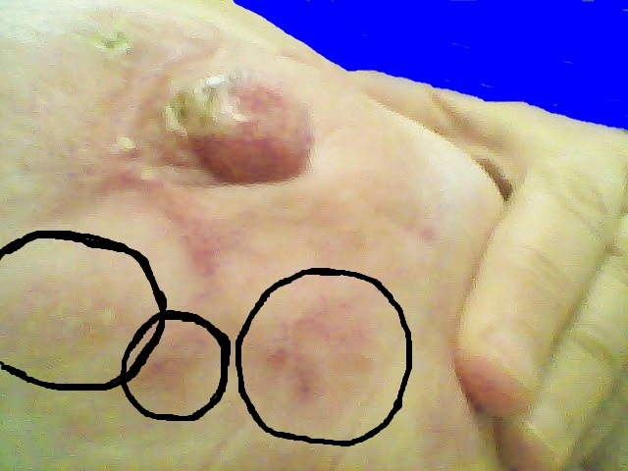
January 16, 10:45:58 |  |  |  |  |  |  |  |  |  |  |  |  |  |  |  |  |  |  |  |  |  | January 16, 10:46:13
Now the little eschars with tell-tale black spots in the middle leave no doubt that the salve has found small pockets of cancer cells, both on the side of the nipple toward where the original tumor spots were, and in the adjacent area.
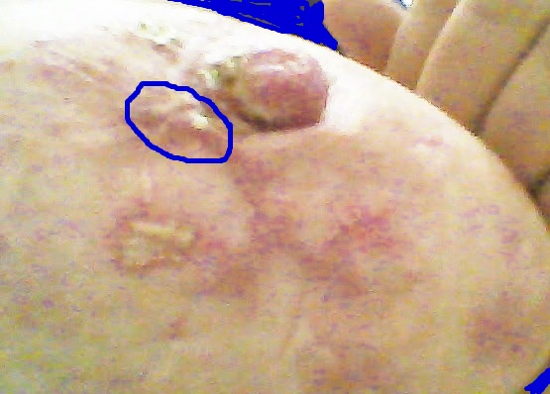 |  |  |  |  |  |  |  |  | 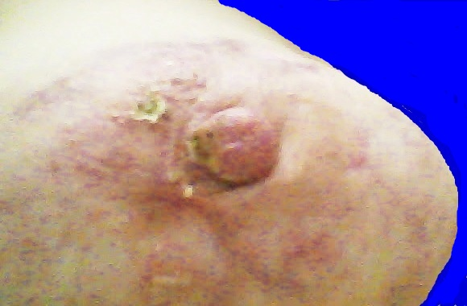
January 17, 15:44:34 |  |  |  |  |  |  |  |  | January 17, 15:44:47
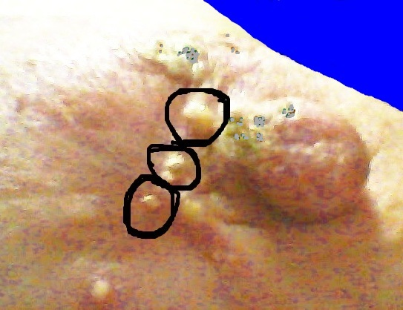 |  |  |  |  |  |  |  |  |  |  |  |  | 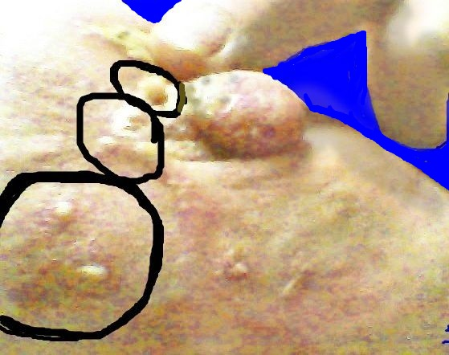
January 19, 00:58:01. Some pustular eruptions were pushing against the skin from inside, and getting ready to break out. |  |  | January 19, 00:59:11. In the top circle, a column of pus has broken out and is standing up on the outside of the skin. In the top two circles, these collections of pus are all on top of the line of scar tissue from the healing of the opening left by the ejection of the first eschar on July 15.
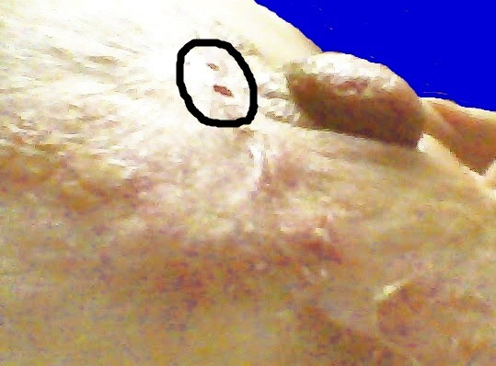 |  |  |  |  |  |  |  |  |  |  |  | 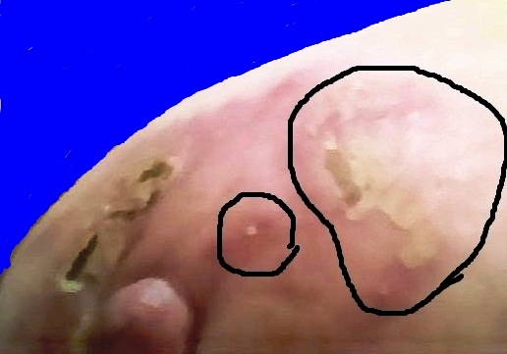
January 19, 01:15:11. In the circle here, we see two small holes left in the epidermis by the two pustular eruptions shown in the previous pictures. This is the first eschar that had pustular eruptions as a prelude to eschar development. |  |  |  |  |  |  |  |  |  |  |  |  |  |  |  |  |  |  |  | January 20, 11:15:57. (1) It’s a good thing I was suspicious of a slightly hard spot on the side of the nipple, or I wouldn’t have known to start using salve again. (2) Here is the first appearance of the “question mark” eschar.
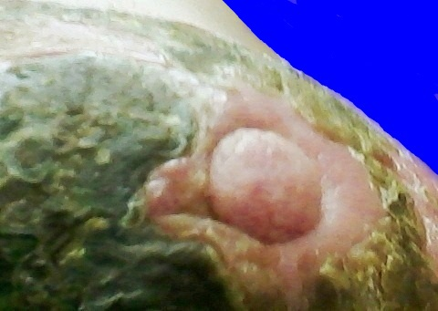
Flashback to July 6 |  |  |  |  |  |  |  |  |  |  | January 20, 16:16:42.
Before the first ejection, no eschar ever formed over the tumor spots that were immediately adjacent to the nipple. Now the pattern is just the opposite. The current eschars must be cleaning up a few cancer cells left over in this spot. |  |  |  |  |  |  |  |  |  |  |  |  |  |  | The “question mark” eschar is approximately at the top, or just above, where the main eschar mass used to be. We also have escharization on the side of the nipple, and in the place where the two little tumor spots used to be.
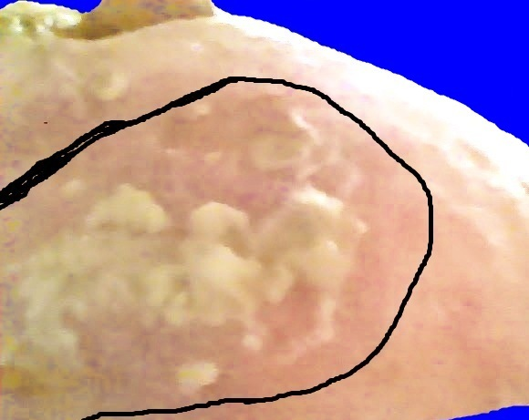 |  |  |  |  |  |  |  |  |  | 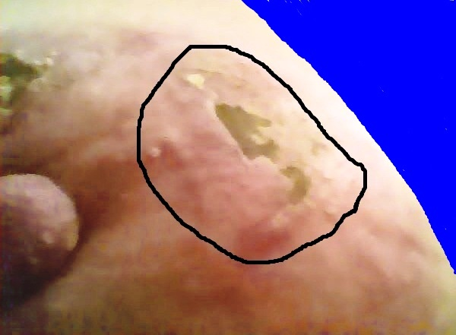
January 21, 10:36:45. Close-up view of the early stage of this development below the nipple — not even any eschar surface, just some sticky debris. |  |  |  |  |  |  |  |  |  |  |  |  |  |  |  |  |  |  |  |  | January 21, 10:32:13. (1) The eschar formation in the circle above continues to grow. (2) See tiny white spots on the nipple.
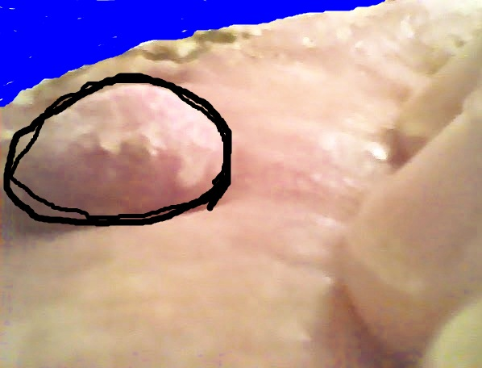 |  |  |  |  |  |  |  |  |  |  |  |  |  |  |  |  |  | 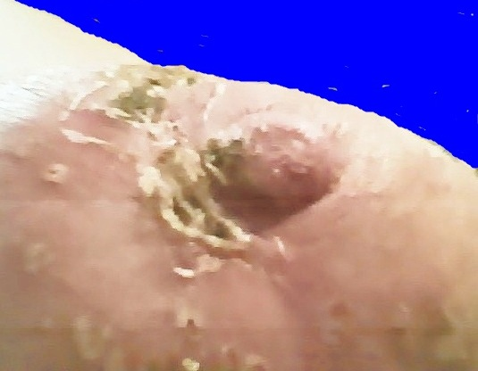
January 21, 10:35:36. Pin-prick eschars on the nipple surface | January 22, 15:47:16. (1) Some little specks of black surface on both sides of the nipple have fallen off. There are now three sections of eschar material where the two little tumor spots used to be beside the nipple.
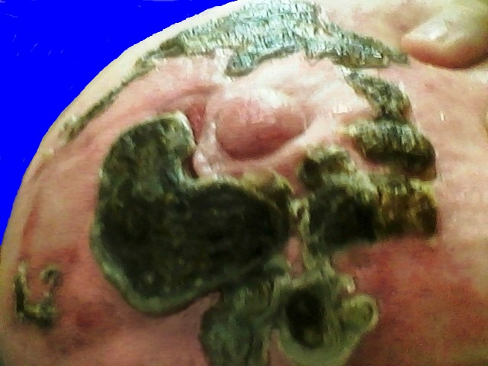  Flashback to July 13 |  |  |  |  |  |  |  |  |  |  |  |  |  |  |  | 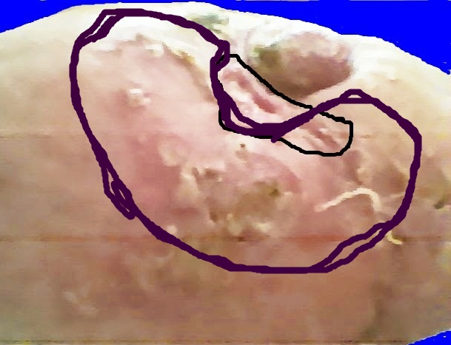
Compare the area of escharization in the picture on the right with this picture from July 13. The one on the right looks like it could have a few residual cancer cells left over from this ejection. |  |  |  |  |  |  |  |  |  |  |  |  |  |  |  |  | January 23, 14:22:54. (1) There is still a small eschar on the side of the nipple, but (2) the small eschars right beside the nipple have fallen out.
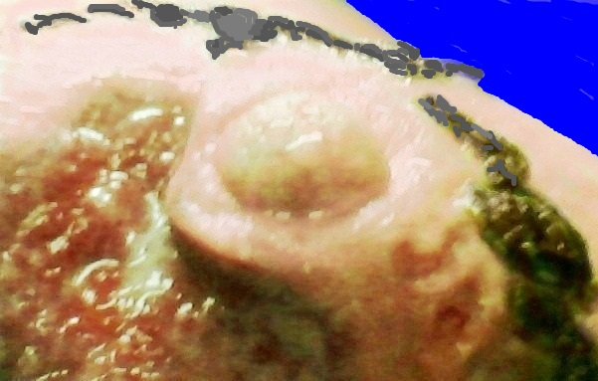 |  |  |  |  |  |  |  |  |  |  |  |  |  |  |  | Remember the picture from July 15, right after the ejection of the first and largest eschar. A small pool of white stuff is right next to the edge of the decavitation, close to the nipple. Could this white stuff be cancer cells that came too late to catch the train? In other words, they were drawn to this area AFTER the membrane around the debris on the back of the eschar surface had already been sealed up, making a sac or pocket of waste that contained dead cancer cells. Could that be why there were pustular eruptions along the line of scar tissue where this decavitation had closed and healed?
Flashback to July 15
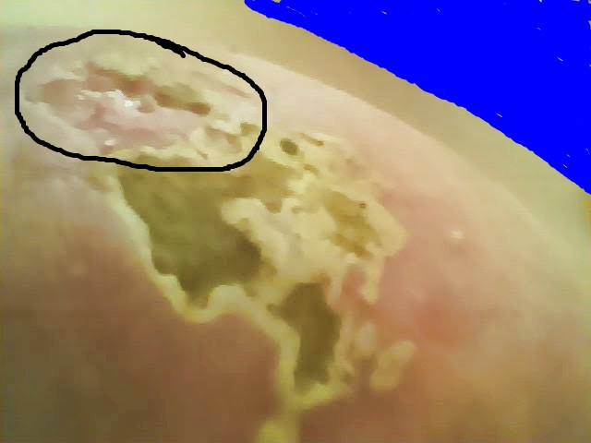 |  |  |  |  |  |  |  |  |  |  |  |  |  |  |  | 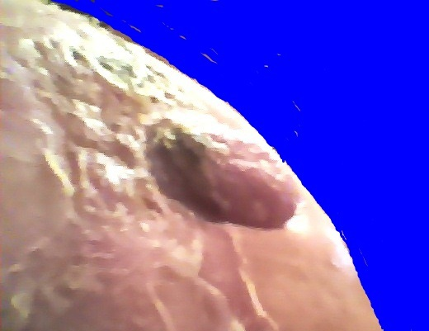
January 23, 14:25:05 |  |  |  |  |  |  |  |  |  |  |  |  |  |  |  | January 24, 14:52:09.
Above, right: The eschar on the side of the nipple is a fairly small spot, but is big in relation to the amount of space on the side of the nipple. I don’t think it would react like this if there were not something behind it; therefore, I am glad the hard spot, which I first felt on the 7th of January, gave me a warning that I needed to go back and do a mop-up operation.
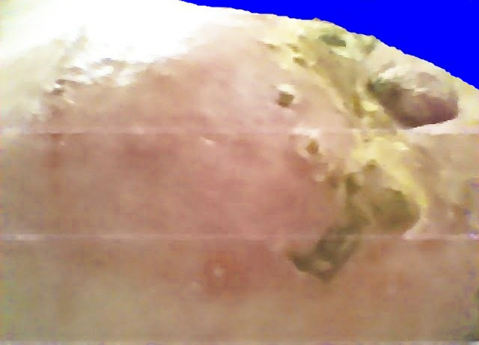 |  |  |  |  |  |  |  |  |  |  |  |  |  |  | 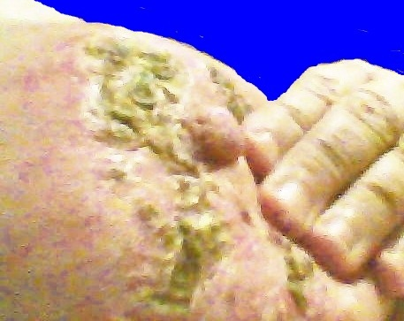
January 25, 4:14:48. Notice the new small eschars out around the edge of where the old main eschar mass used to be. |  |  |  |  |  |  |  | January 26, 21:11:46. You can still see a little hole in the side of the nipple where the small eschar in the previous picture had been attached.
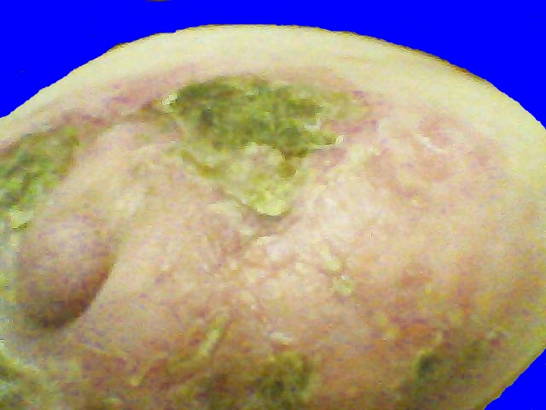 |  |  |  |  | 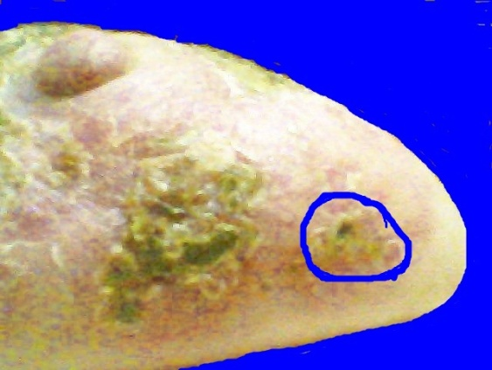 |  |  |  |  |  |  |  |  |  |  |  |  |  |  |  |  |  |  |  |  |  |  | 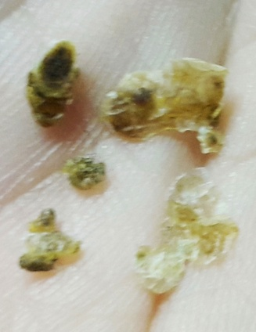
January 28, 00:11:00. (1) You can see the spread of the eschar at the top. (2) Also, there was a small eschar on the side of the nipple again, but it was very temporary, and has already fallen off. Maybe it took out a few more cancer cells. |  |  |  | January 28, 00:11:34. (1) See the increased escharotic activity in the lower part of where the salve and bandage were last night. (2) Keep watch on the spot that is circled. There may have been a tiny bit of cancer left over from the large eschar that was there earlier. |  |  |  |  |  |  |  |  |  |  |  |  |  |  |  |  |  |  |  |  |  |  |  |  | January 28, 20:14:51. These were some loose scraps that chipped off during the afternoon.
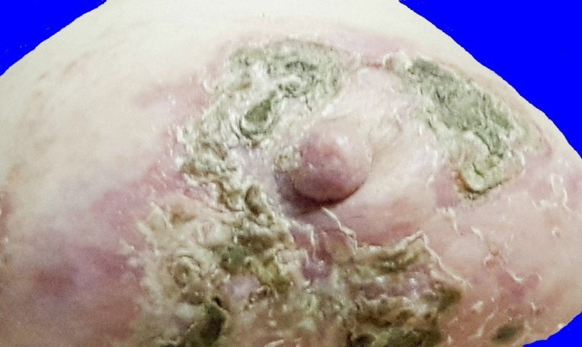 |  |  |  |  |  |  |  |  |  |  |  |  |  |  |  |  |  |  | 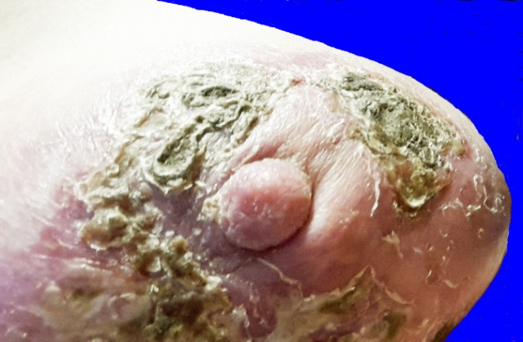
January 28, 20:32:56. The reason the scraps in the previous picture chipped off so easily was that they were all small, shallow, and disconnected from each other. |  |  |  |  |  |  |  |  |  |  |  |  |  |  |  |  |  |  |  |  |  |  | January 28, 20:54:31. (1) More loose scraps are getting ready to fall off. (2) Another small eschar has formed on the side of the nipple.
Look back 2-3 pages at the the flashback pictures from July 6, 13, and 15. The unaffected parts of the areola are about the same as the pictures above. There is very little unaffected area on the left side of the areola and the upper part, but much more unaffected area on the other side.
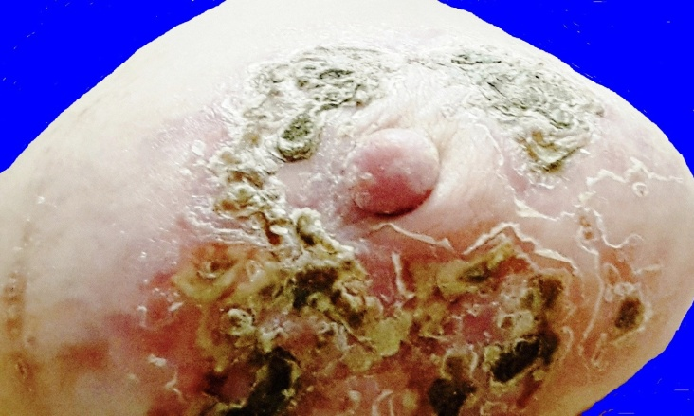 |  |  |  |  |  |  |  |  |  |  |  |  |  | 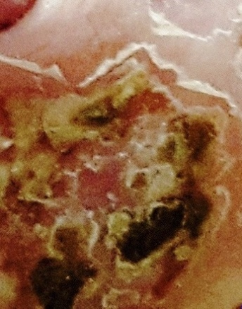 |  |  |  |  |  |  |  |  |  |  |  |  | 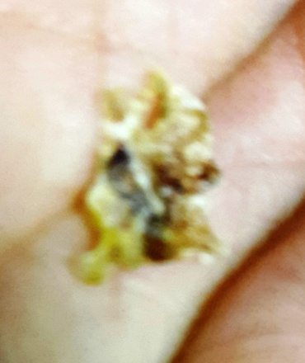
January 29, 21:03:29. (1) The small eschar that was on the side of the nipple in the previous picture has chipped off (again). (2) The question mark eschar is still hanging on. (3) The skin is pealing around the remaining eschars. |  |  |  |  |  |  | January 29, 21:03:29. This is an enlargement of the area in the center of the previous picture where a leaf-shape piece fell out. |  |  |  |  |  |  |  |  |  |  |  |  |  |  |  |  |  |  | Jan. 29, 16:49:50. The two previous pictures, and both of the pictures in the next row, show where this multi- lobed and multi-colored leaf shape fell out.
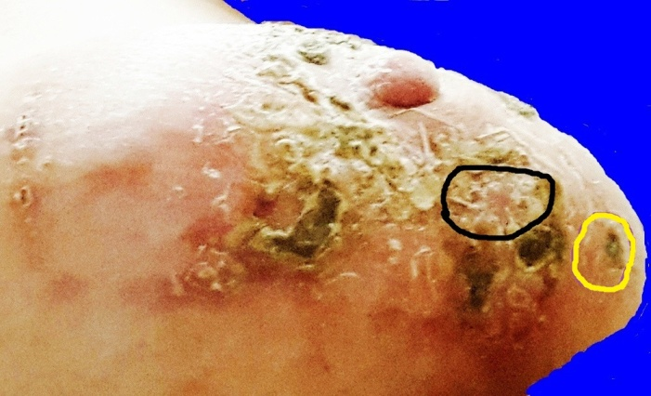 |  |  |  |  |  |  |  |  |  |  | 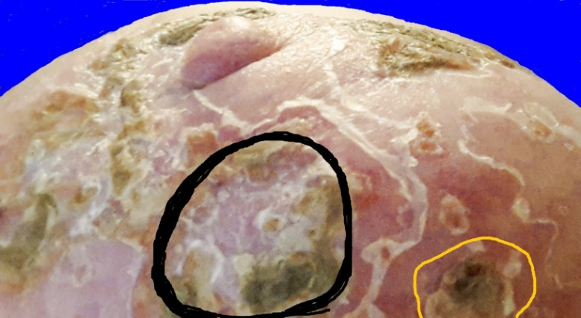
January 29, 21:03:19. In spite of the confusion of many disorganized small pieces, some thick deeply seated eschars have developed across the lower part of the breast. |  |  |  |  |  |  |  |  |  |  | January 30, 11:33:08. So far none of the bits of eschar material that have fallen off have had any debris attached to the back of the eschar except for very tiny bits.

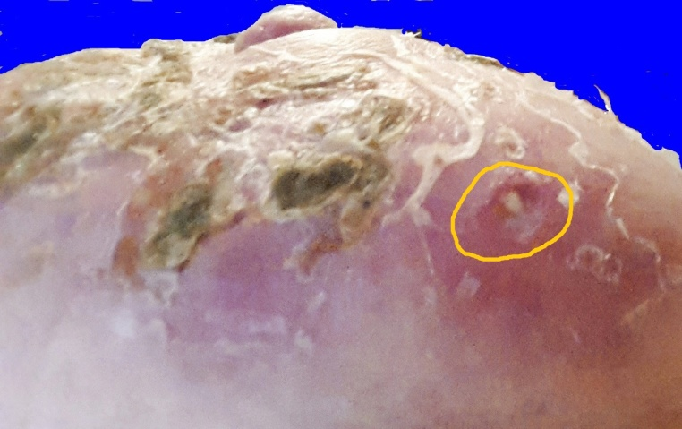 |  |  |  |  |  |  |  |  |  |  |  | 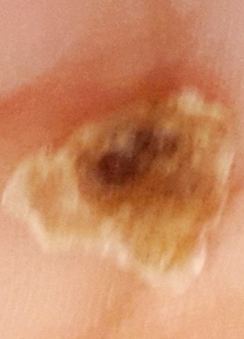 |  |  |  |  |  |  |  |  |  |  |  |  |  |  |  |  |  |  |  | 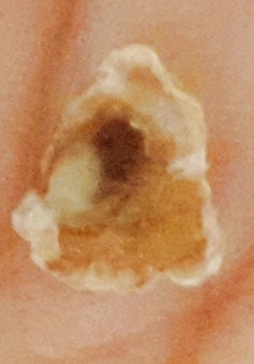
January 30, 11:36:17. (1) The eschar surface has become detached. (It was circled in the last two pictures.) (2) The pus inside is not like most eschars. It is more of a viscous liquid than a semi-solid. (3) If you go back and look at the last major eschar (August 5 — August 18), (the one I called the “sailboat eschar”) and look at the faded hyperpigmentation above, you can see that this repetitious little eschar spot has grown where part of the “sailboat” eschar used to be. There was apparently a small leftover cancer hotspot there. |  |  |  |  |  |  |  |  |  |  |  |  |  |  |  |  |  |  |  |  |  |  |  |  |  |  |  | Jan. 30 11:37:58 & 11:43:08. Front and back of ejected eschar. Although this small thin eschar had two black spots, only one of them appears to have had a column of pus attached to the back.
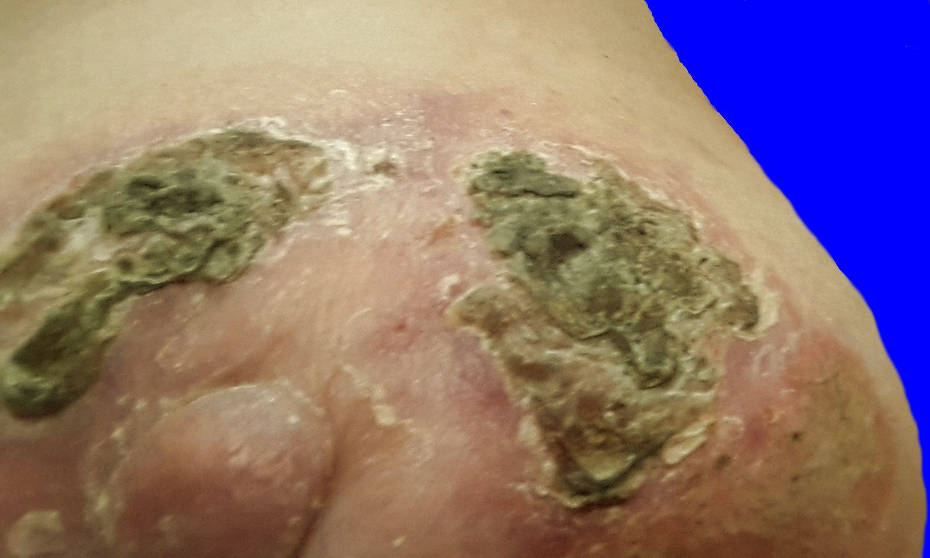 |  |  |  |  |  |  |  |  |  |  |  |  | 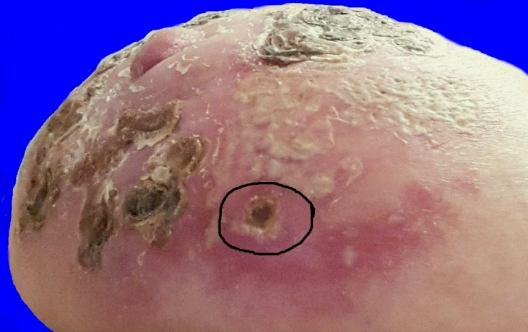
January 31, 20:08:02. (1) You can still see the original eschar mass on the right side of the picture, and lines of separation between the original part, and the parts that have been added on. (2) You can also still see the question mark shape on the other side. |  |  |  |  |  |  |  |  |  |  |  |  |  |  |  |  |  |  | January 31, 20:14:21. (1) There is a new small eschar surface replacing the one that fell off yesterday. (2) The imprint of the leaf shape is still there from two days ago.
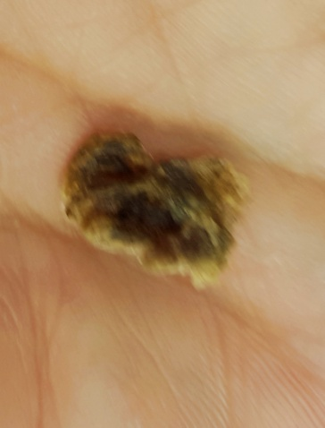 | 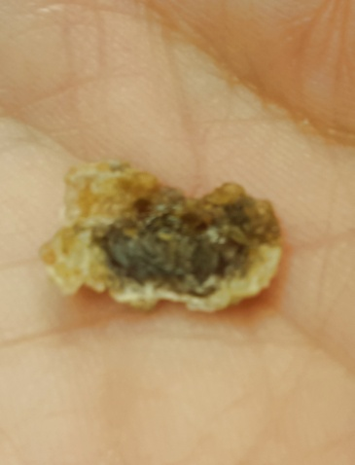 |  |  |  |  |  |  |  |  |  | 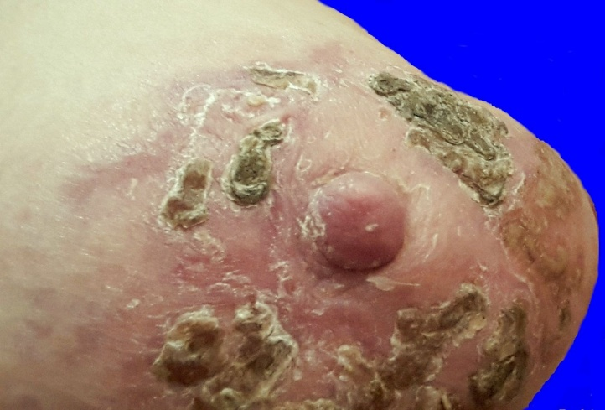
Feb. 1, 21:36:41 and 21:37:26. The top of the question mark shape finally fell off. I thought there would be at least a little bit of debris on the back, but surprisingly, there was almost nothing. |  |  | Feb. 1, 21:39:29. In this picture, you can see the bottom part of the question mark, and you can still see the outline of the top part that has just ejected. The side of the nipple looks like a new small eschar is trying to form. I think there is a little bit of tumor material there because it still feels hard.
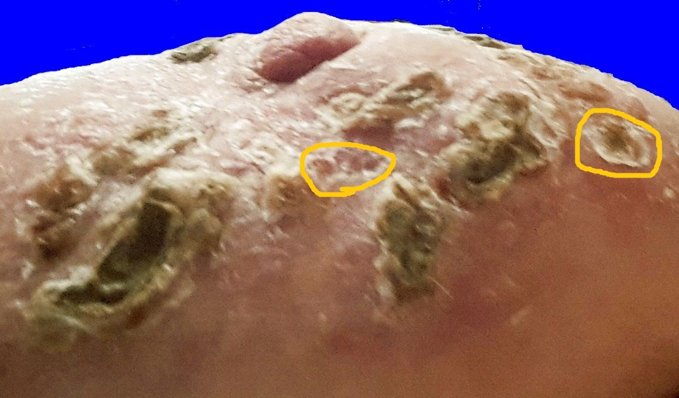 |  |  |  |  |  |  |  |  | 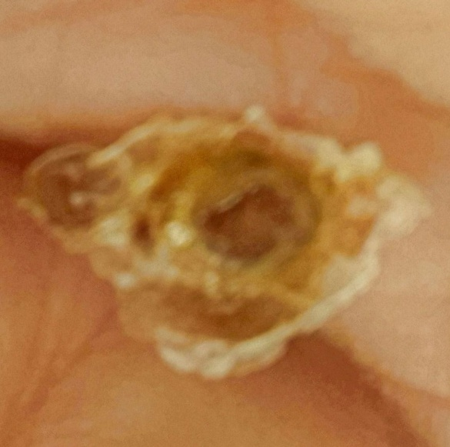 |  |  |  |  |  |  |  |  |  |  |  |  |  |  |  |  |  |  |  |  | 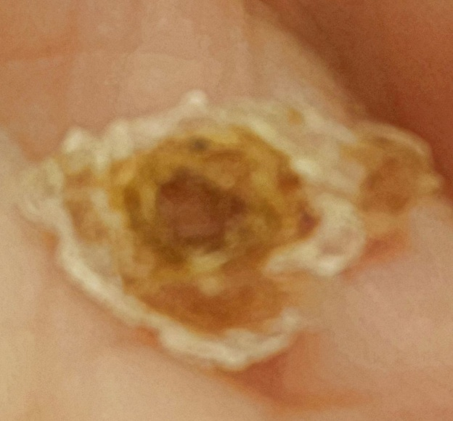
 |  |  |  |  |  |  |  |  | February 2, 23:21:47. This is the outside of the thin eschar surface that you saw in the previous picture. This is the SECOND ejection in this spot. |  |  |  |  |  |  |  |  |  |  |  |  |  |  |  |  |  |  |  | February 2, 23:21:27. This is the inside of the eschar surface. The white spot near the bottom of the dark center appears to be a little bit of pustular debris that was pulled out.
February 2, 23:18:16. Inside the circle on the far right is the 2nd eschar surface in this spot.
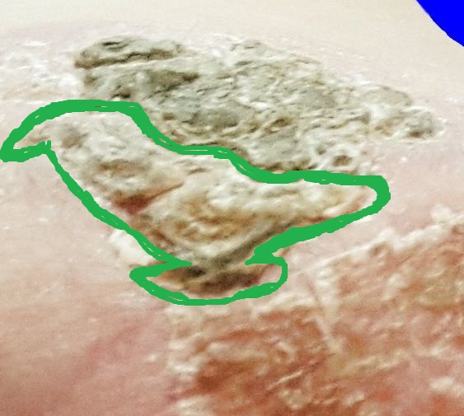
 |  |  |  |  |  |  |  |  | 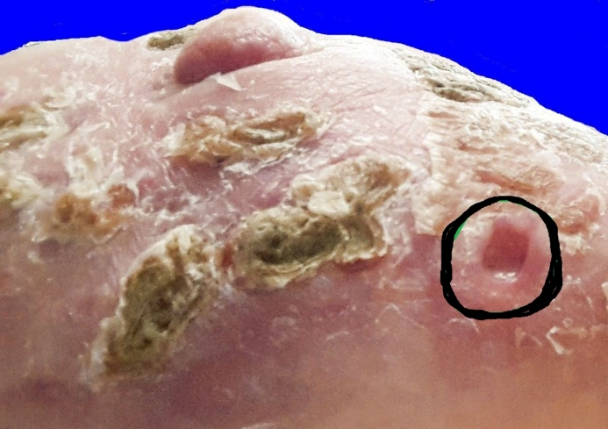
Feb. 2, 14:58:16. This looks like a bird perched on a rock. I could not have dreamed up such a fancy eschar like a carving of a bird where you can see the beak, the eye, the feathers, the tail, and even little feet. (Why have eschars if they are not entertaining? Aren’t we supposed to have a ball doing this stuff?) |  |  |  |  |  |  |  |  |  |  |  |  |  |  |  |  | February 2, 23:20:31. The small hole in the skin, where the above eschar has just ejected, is one of only two very small decavitations in this entire series of superficial eschars that occurred in response to the round of salve in Jan. through March.
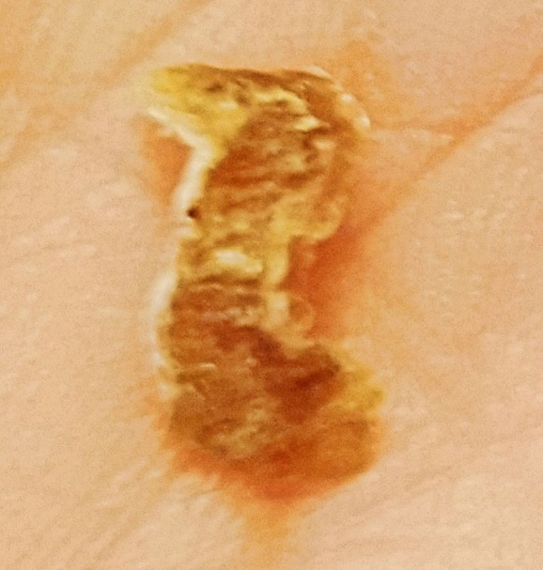 |  |  |  |  | 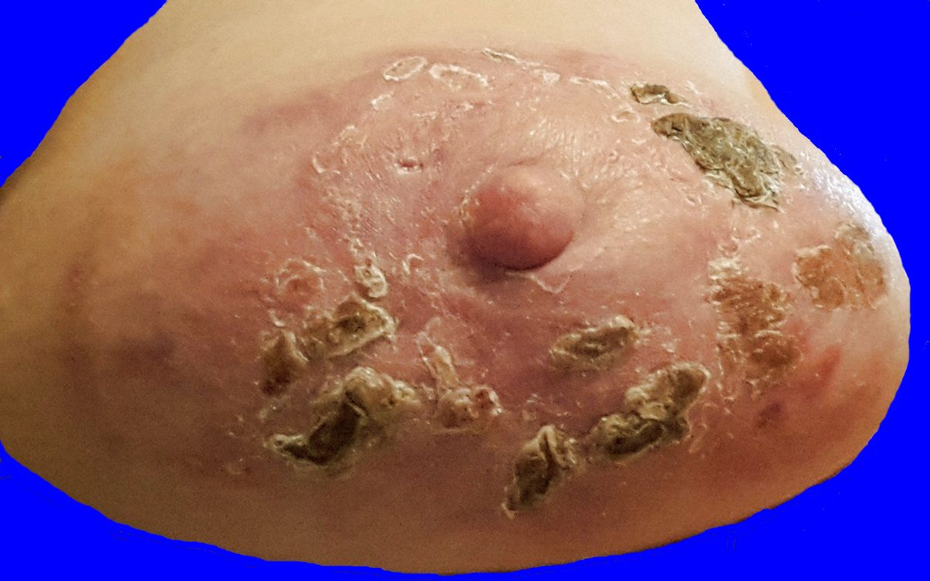  February 3, 09:50:33. The bird has flown away. The question mark eschar is also completely gone.
(Left) Feb. 3, 09:51:40. The bird fell off late last night. Part of his tail got separated from the rest of his body because the eschar is drying out.
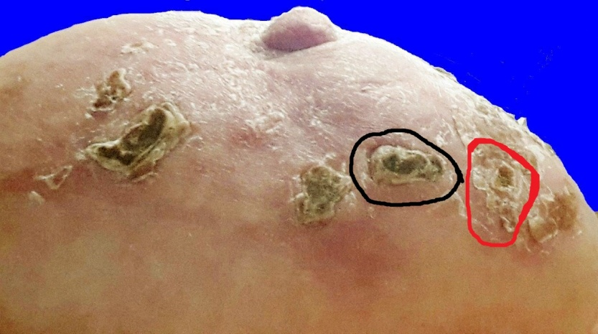 |  |  |  |  |  |  |  |  |  |  |  |  |  |  |  |  |  |  |  |  |  |  |  |  |  |  | 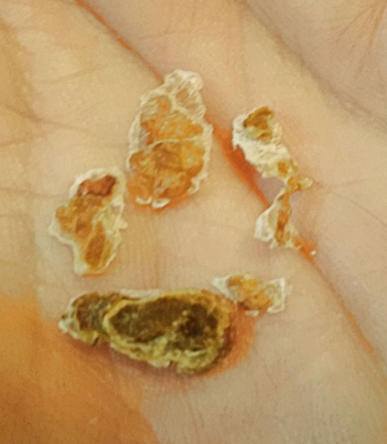
Feb. 7, 00:32:38. In the black circle, you see one eschar on top of another one. You can see there is a lot of separation, so they are about ready to eject. In the red circle is another eschar surface where there was an ejection on Feb. 2. |  |  |  |  |  |  |  |  |  |  |  |  |  |  |  |  |  |  |  |  |  |  |  | Feb. 7, 11:21:57. The two eschars that were stacked one on top another are now history along with a few other small superficial scraps.
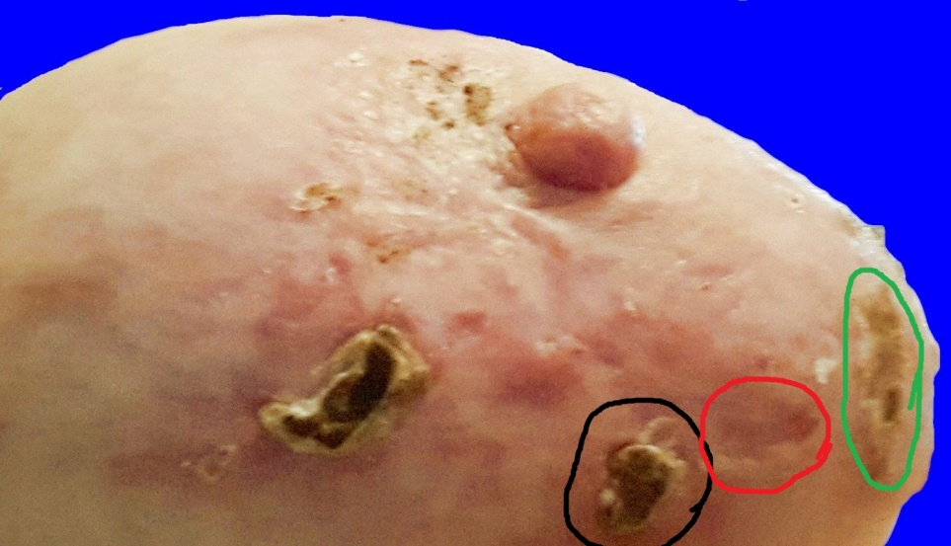 |  |  |  |  |  |  |  |  |  |  |  |  |  |  |  |  |  |  |  | 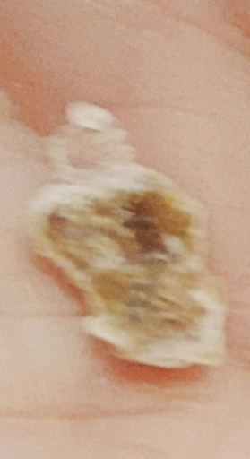 |  |  |  |  |  |  |  |  |  |  |  |  | 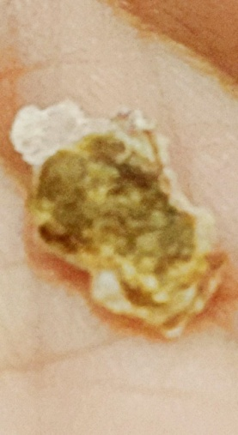
Feb. 7, 11:36:16. In the black circle, the next eschar is loose and about ready to fall off. In the red circle is a slightly purple indentation where the last eschar fell out. In the green circle is the 3rd eschar surface in the same place. |  |  |  |  |  |  |  |  |  |  |  |  |  |  |  |  |  |  |  |  |  |  | Feb. 7, 12:43: 14 & 12:43:36. Another eschar bites the dust — the one that is circled in black in the previous picture.
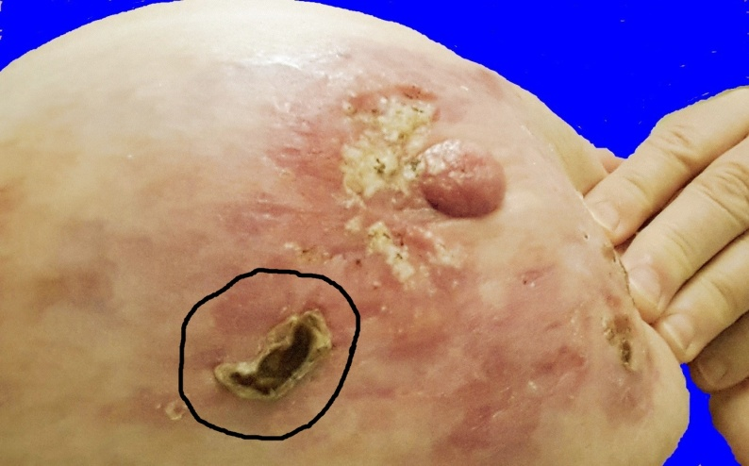 |  |  |  |  |  |  |  |  |  |  |  |  |  |  |  |  |  | 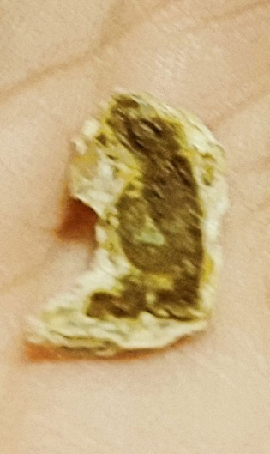 |  |  |  |  |  |  |  |  |  |  |  |  |  |  | 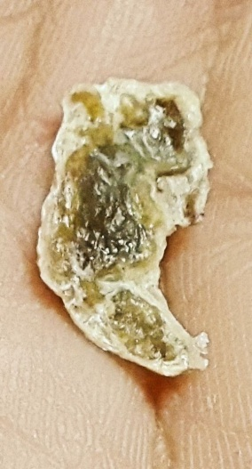
Feb. 8, 07:51:24. One remaining of the row of small, but thick and tough eschars. More new escharization on the side of the nipple, and in the area of the first eschar. |  |  |  |  |  |  |  |  |  |  |  |  |  |  |  |  |  |  | Feb. 8, 19:37:26 Feb. 8, 19:38:04  Front and back of ejected eschar.
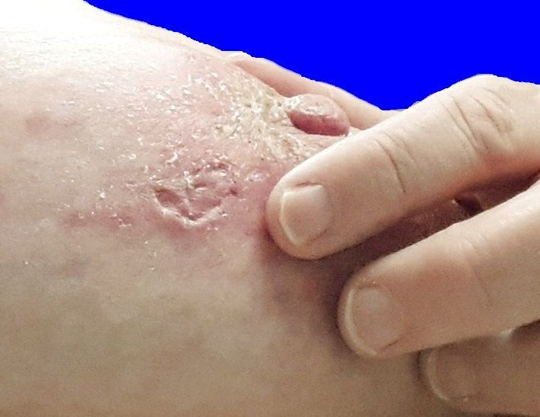 |  |  |  |  |  | 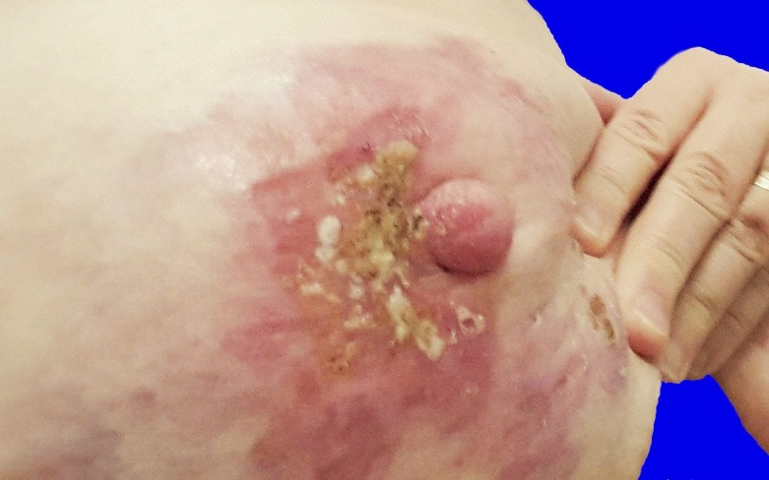
February 8, 20:38:58 You can see where the eschar that just ejected had been hanging on very tightly, but it did NOT hurt. |  |  |  |  |  | February 9, 10:58:04. Escharization on the side of the nipple and in the area of the first eschar, due to the application of salve in the last couple days.
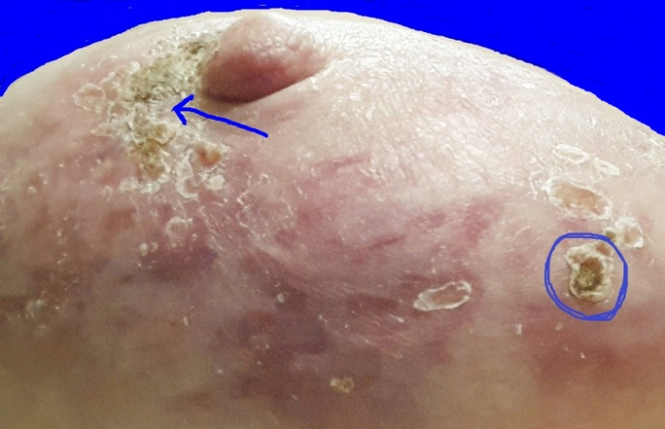 |  |  |  |  |  |  |  |  |  |  |  | 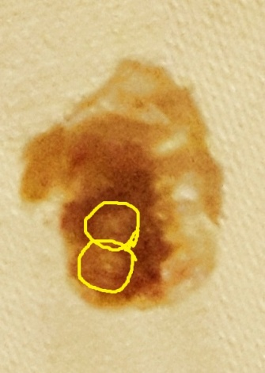 |  |  |  |  |  |  |  |  |  |  |  |  |  |  |  |  |  |  | 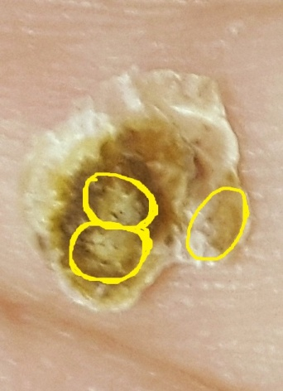
Feb. 10, 22:37:35. The escharization in the same place as the original eschar is brittle and falling apart. (2) Also notice further development of the third eschar surface in the same place where two previous eschars have been ejected. |  | Feb. 11, 05:19:38. (Center) This is the THIRD ejection in this same spot. This is the front of the small eschar surface. You can see two little light-colored spots on the surface. |  |  |  |  |  |  |  |  |  |  |  |  |  |  |  |  |  |  | Feb. 11, 05:20:00. (Far right) This is the back where this eschar surface was attached to the skin. Three distinct spots are a lighter color, and look rough and worn down. Even though there is no hole in the skin. Did a small amount of cancerous debris come out in these three spots?
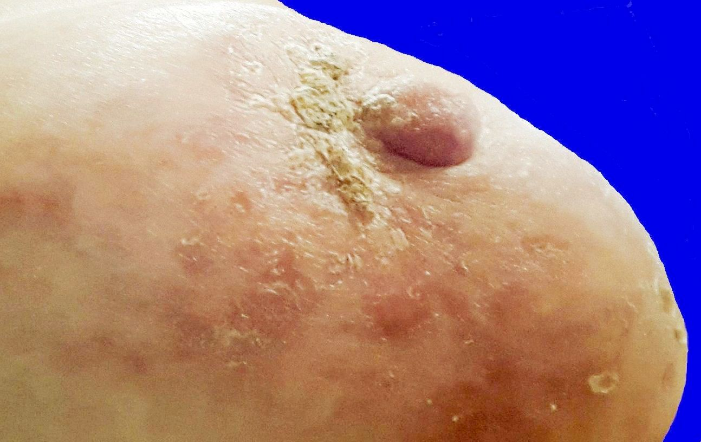 |  |  |  |  |  |  |  |  |  |  |  |  |  |  |  |  |  |  |  |  |  |  |  |  |  |  | 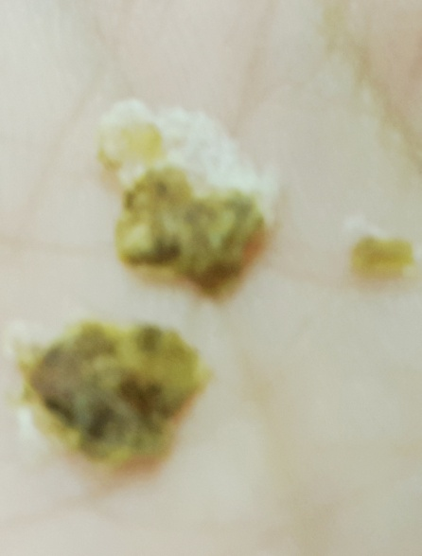
 |  |  |  |  |  |  |  |  |  |  |  |  |  |  |  |  |  |  |  |  |  |  |  |  |  |  | Feb. 14, 00:58:32
Feb. 12, 09:24:59. Superficial escharization where the biggest eschar used to be, is brittle and cracking even more. There is still an eschar surface on the side of the nipple.
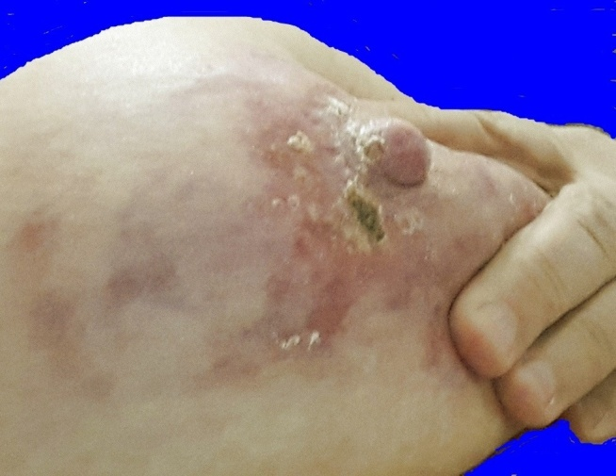 |  |  |  |  |  | 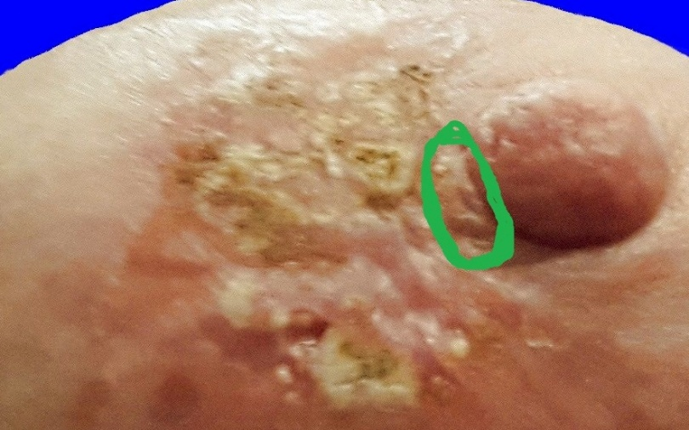
Feb.14, 00:59:27. The brittle escharization now has just one small piece left, but the eschar on the side of the nipple is still there. |  |  |  |  |  |  |  |  | Feb. 15, 11:18:47. A new escharotic development in response to salve. There is still a raised place beside the base of the nipple.
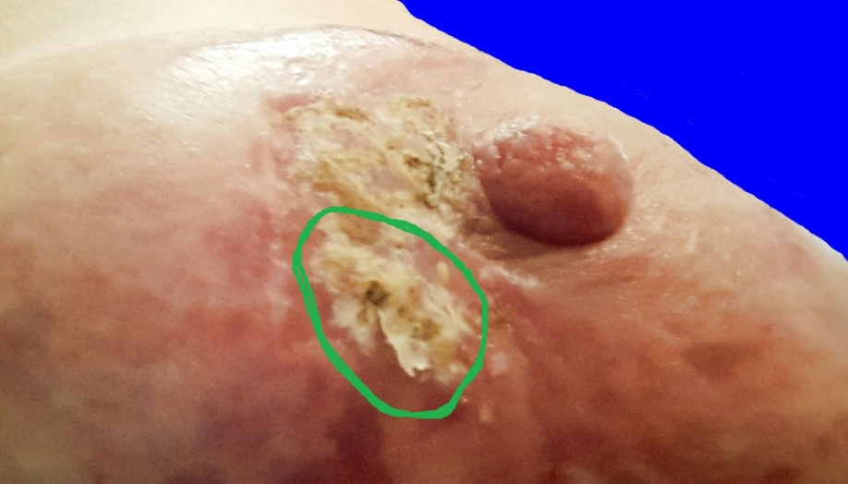 |  |  |  |  |  |  |  |  |  |  |  |  |  |  |  |  |  |  |  |  |  |  |  |  | 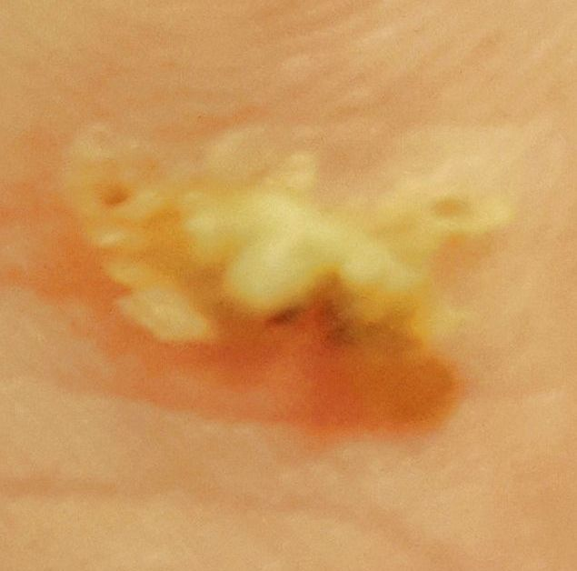
Feb. 16, 10:67:40. A shallow eschar with a funny eschar surface. Only a tiny spot is solidified like a normal eschar surface. |  |  |  |  |  |  |  |  |  |  |  |  |  |  |  | Feb. 16, 12:04:14. The same surface with a little bit of debris behind it is now upside down in my hand.
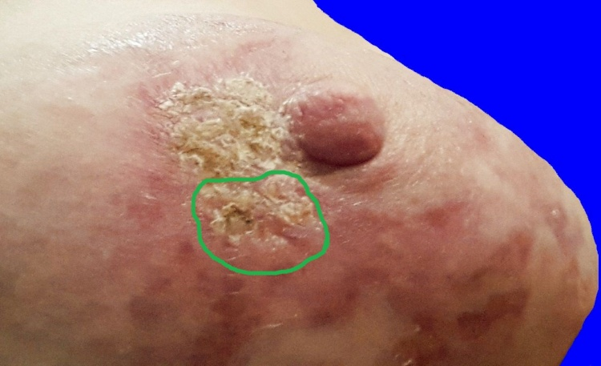 |  |  |  |  |  |  |  |  |  | 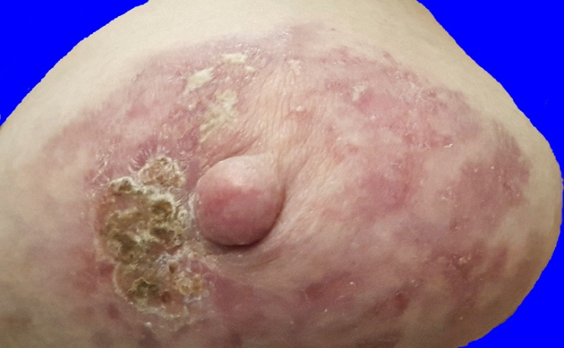
Feb. 16, 22:26:27. New escharization beside the nipple in response to salve there. |  |  |  |  | Feb. 18, 01:24:01. A little bit of new escharization is spreading above the nipple due to an application of salve there.
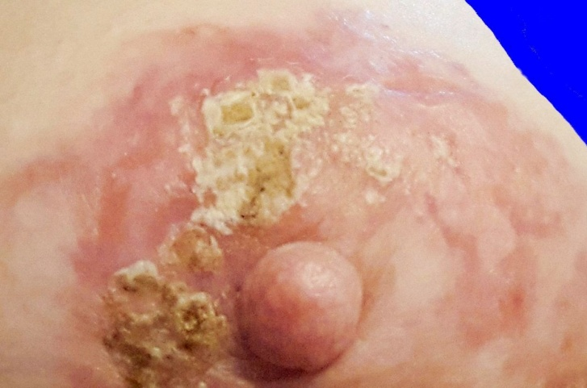 |  |  |  |  |  |  | 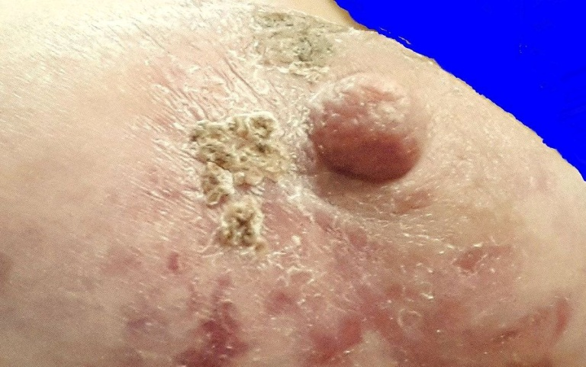
Feb. 19, 13:04:23. With another application of salve above the nipple, new escharization is spreading, but the patch on the side is beginning to fall apart. |  |  |  |  |  |  |  |  |  |  |  |  |  |  |  | Feb. 20, 21:33:15. The top patch of eschars has become solidified, and the side patch is continuing to fall apart.
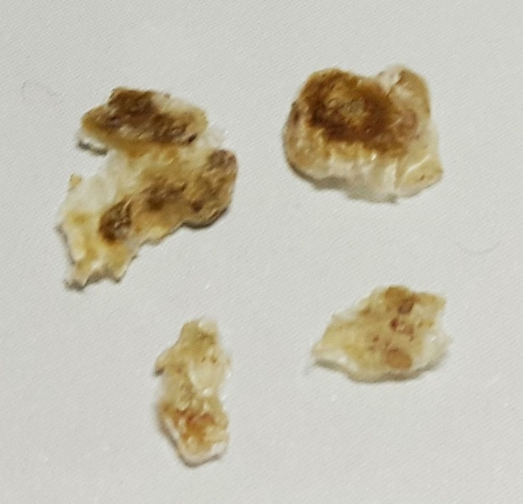 |  |  |  | 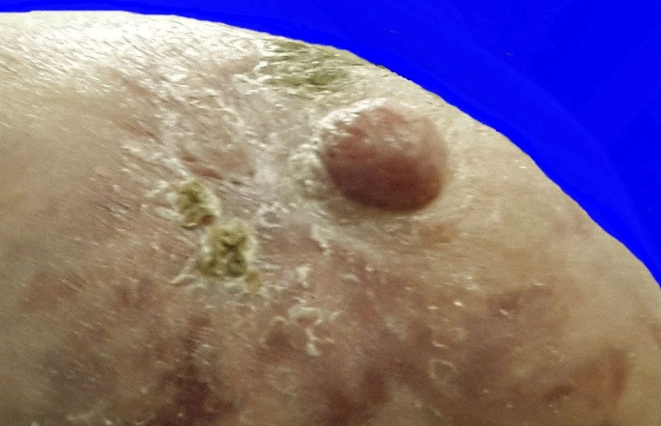
Feb. 21, 01:11:04. Another handful of disconnected small pieces has fallen off from the eschar mass at the side. |  |  |  |  |  |  |  |  |  |  |  |  |  |  |  |  |  |  |  |  |  | Feb. 21, 01:16:07. The side eschar is almost gone.
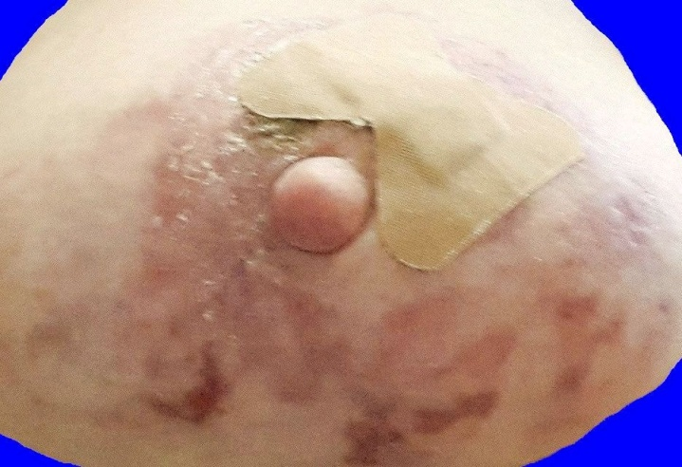 |  |  |  |  |  |  |  | 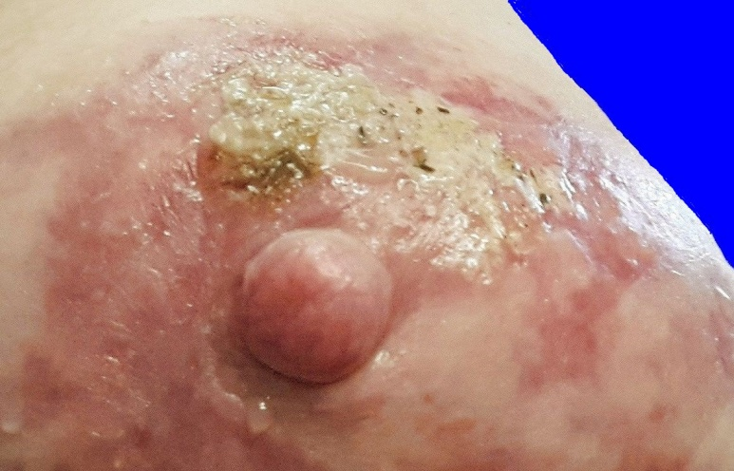
Feb. 21, 13:57:25. This band-aid is from a new application of salve last night. Most of the old hyperpigmentation is fairly well faded, but the intensely purple spots are from recent eschars. |  |  |  |  |  |  |  | Feb. 21, 13:59:15. This is a strange eschar patch. The only solid surface is what was already there, just above the nipple, but the new part has no solid surface.
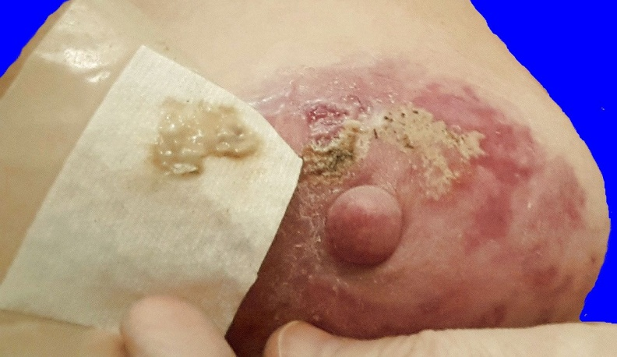 |  |  |  |  |  |  |  |  |  |  |  |  |  | 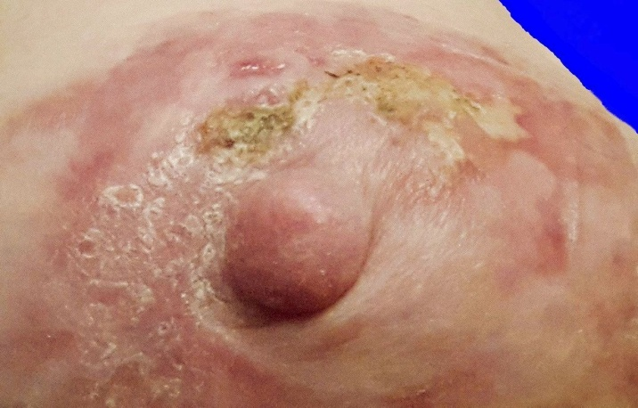
Feb. 22, 00:23:56. In the eschar patch at the top, the debris sticks to the band-aid, and leaves a decavitation in the skin when the band-aid comes off. I guess you would call this a small ejection of debris from just under the surface of the skin. |  |  |  |  |  |  |  |  |  |  |  |  |  |  |  |  |  |  |  |  |  |  |  |  |  | Feb. 22, 22:42:13. The eschar surface at the top begins to dry out, and form a thin surface. The eschar patch at the side is gone.
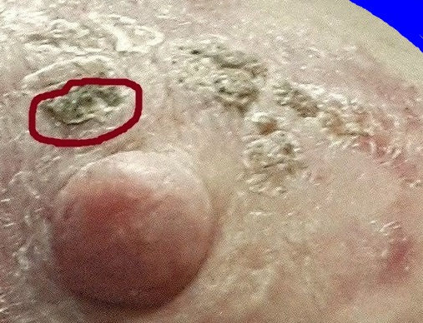 |  |  |  |  |  |  |  |  |  |  |  |  |  |  | 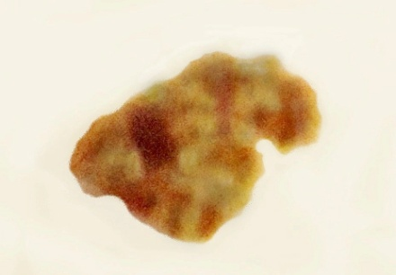 |  |  |  |  |  |  |  |  |  |  |  |  |  |  |  |  |  |  | Feb. 25, 05:03:24. This is the top of the eschar that is circled in the picture to the left.
 |  |  |  |  |  |  |  |  |  |  |  |  |  |  | 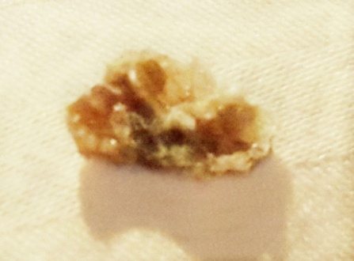 |  |  |  |  |  |  |  |  |  |  |  |  |  |  |  |  |  |  | Feb. 25, 05:05:05. The underneath side of the same eschar as above. The Inside has pathways resembling honeycomb inside a beehive.
Feb. 24, 23:09:28
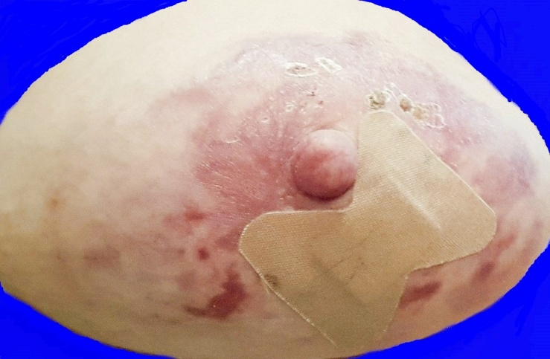 |  |  |  |  |  |  |  |  |  |  |  |  | 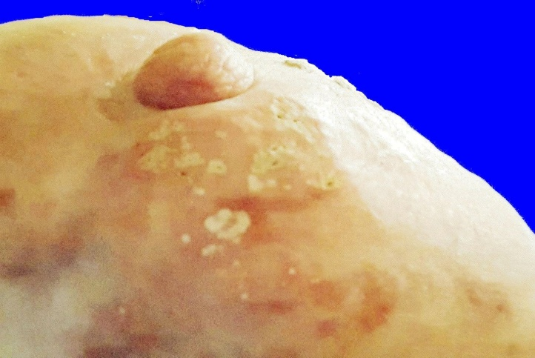
Feb. 26, 14:21:38. Most of the previous escharization is gone, but the band-aid indicates an application of salve, so what did the salve produce? |  |  |  |  |  |  |  |  |  |  |  |  | Feb. 26, 14:40:24. After a month and a half since January 12, of applying salve and seeing what happens, we are still getting mild escharotic reactions.

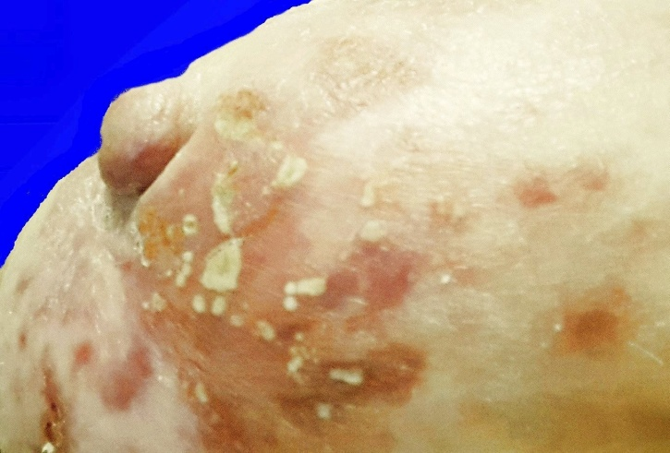 |  | 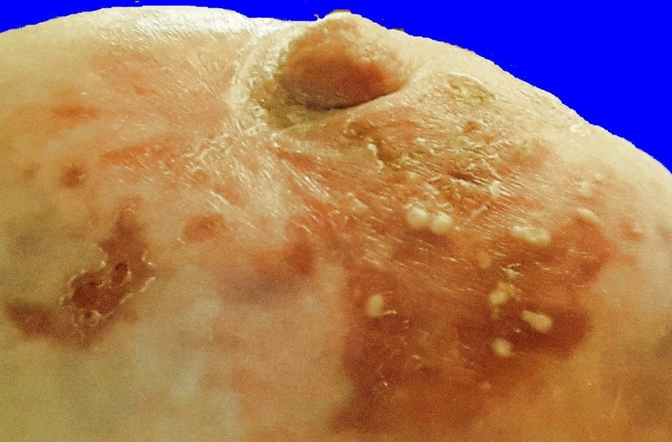
Feb. 27, 21:33:57 |  | Feb. 28, 10:21:48
Above and below: The reaction to salve was so minor that the little dots of debris never even formed an eschar surface. They just dissipated. This was how the debris was ejected.
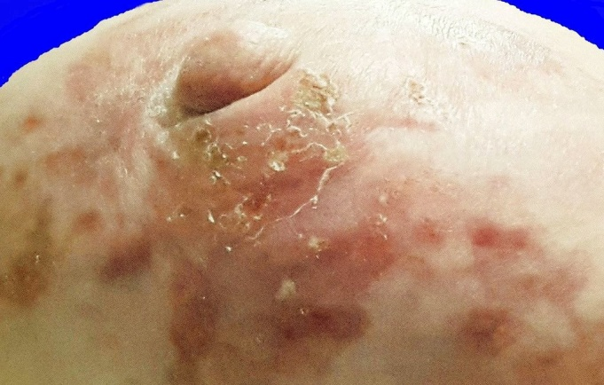 | 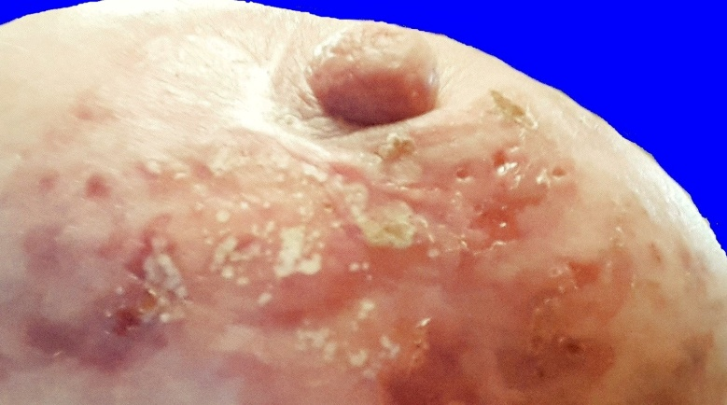

Feb. 28, 20:11:51 | March 1, 16:33:32. After a night of exposure to salve, the above reactions are not even comparable to what you saw in the pictures from June, 2014.

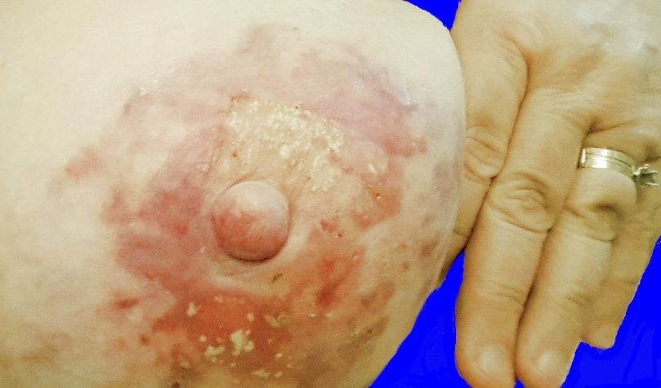 |  | 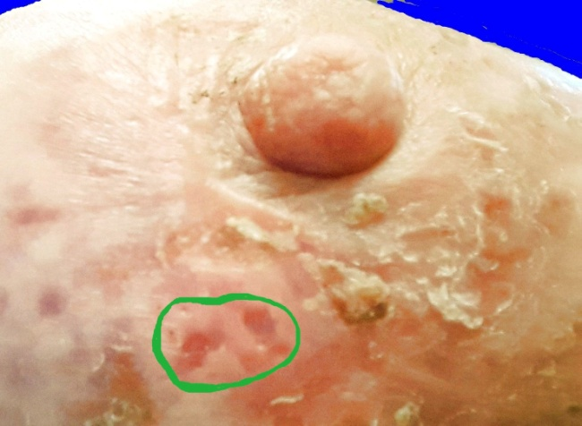
March 2, 11:42:57. You see a slightly yellow rectangle above the nipple where there was a band-aid over the salve last night. The reaction is very minor. | March 3, 11:59:36. You see two very small spots where slightly hardened eschar masses came loose and fell off. They are much smaller than the eschar pieces that came loose a month ago. This operation is fizzling because there isn’t much left of cancerous material to be cleaned out.

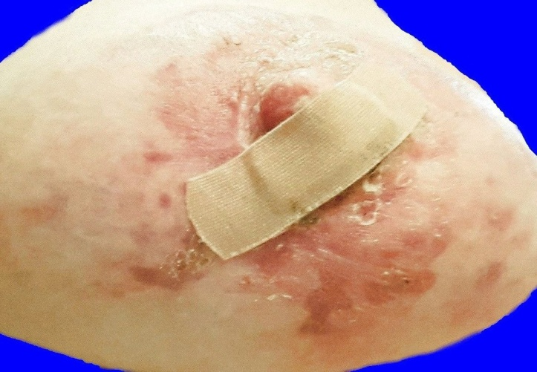 |  | 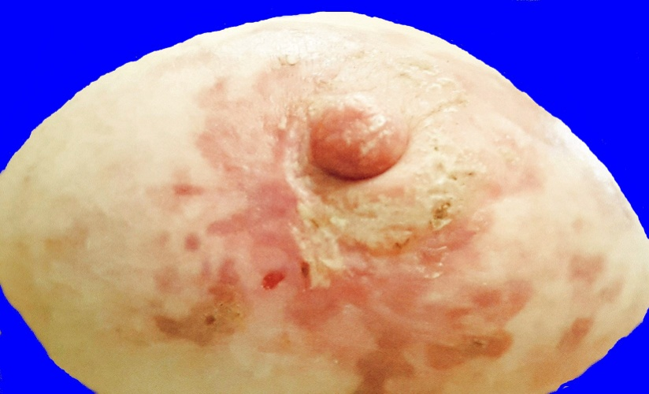
March 4, 11:57:12. This was not intentional. I applied salve BESIDE the nipple, and then tried to place the band-aid out around the nipple, but I obviously didn’t do it right. The band-aid slipped up over the nipple during the night. |  |  |  | March 4, 11:59:10. As a result of the small amount of salve that got on the nipple during the night, there were pin-prick eschar spots on this side of the nipple, and a yellow patch on the skin beside the nipple.
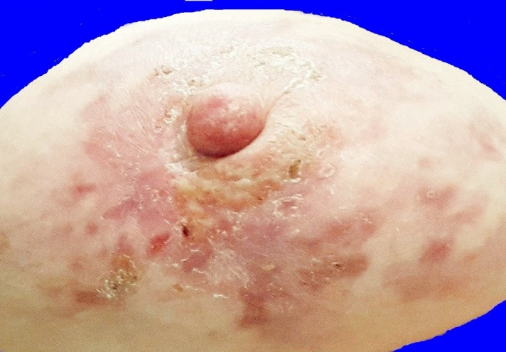 |  |  | 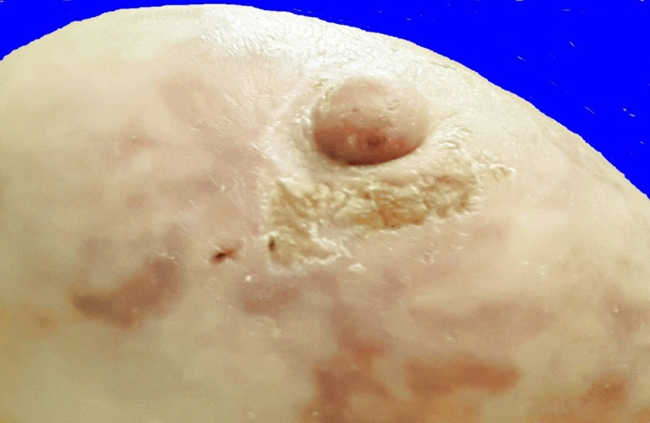
March 4, 23:25:28. By night time, the spots on the nipple were gone or nearly gone, and the yellow patch under the nipple was faint. |  |  | March 6, 22:58:11. In response to more salve, there is a strip of slightly brittle eschar surface that is below the nipple, and slightly to the side.
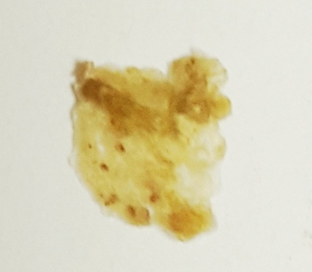 | 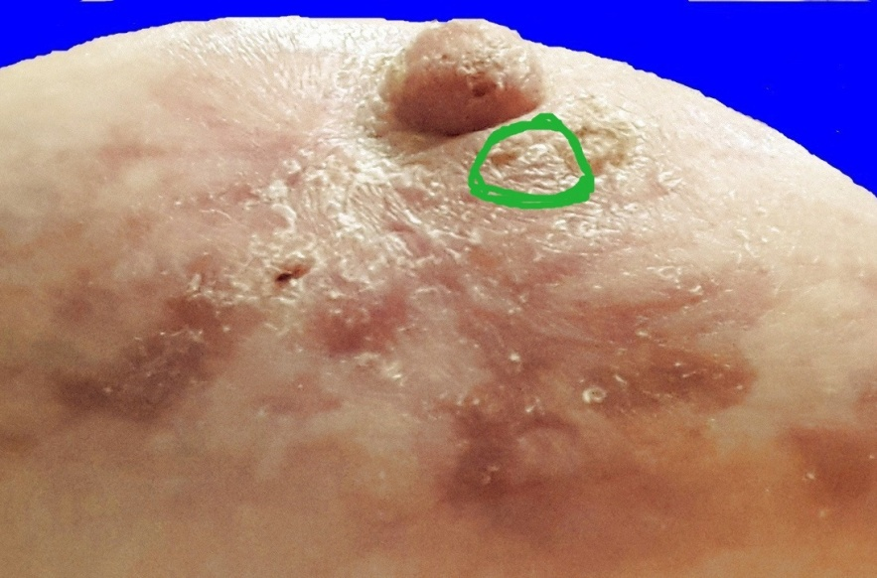
March 7, 21:11:28. By the next night, a piece had broken off, and then the next piece broke off. |  |  |  |  | March 7, 21:38:22. Now only one piece remains of the eschar strip below the nipple.

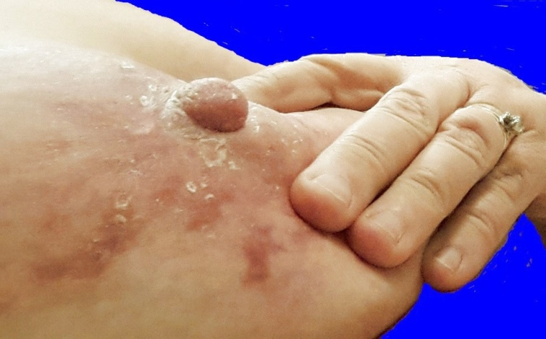 |  |  | 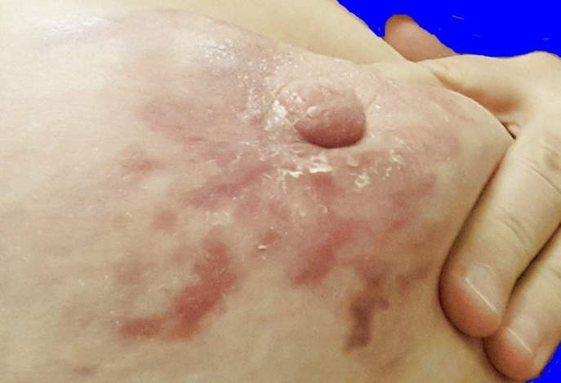
March 8, 23:20:47. The breast is very nearly clear of escharotic material, but it looks like there may be a tiny piece remaining on the side of the nipple. |  |  | March 10, 19:49:17. The tiny dark spot on the side of the nipple from a couple days ago is gone.
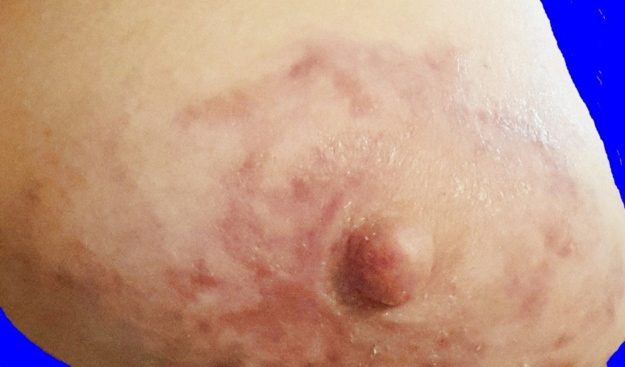 |  |  | 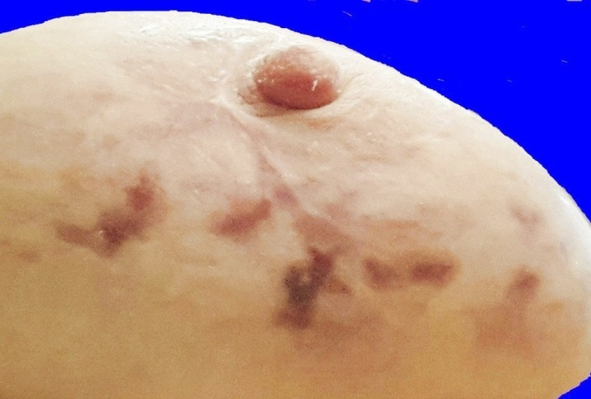
March 14, 12:55:38. Even the flaking skin at the base of the nipple is gone. | March 21, 13:34:28. Now that pretty nearly everything else is gone, the scar tissue and hyperpigmentation become the main things that you see.
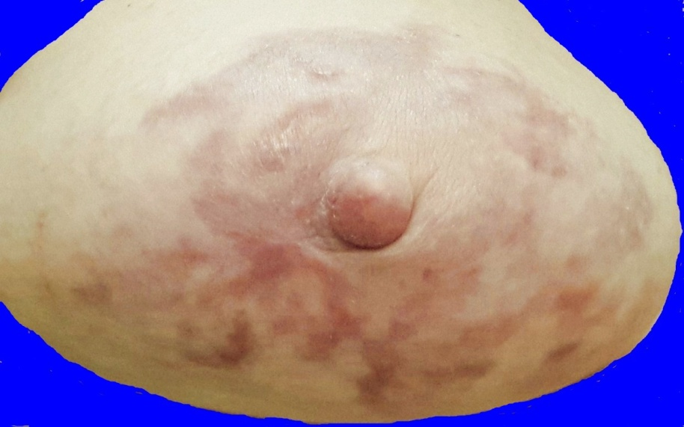 |  | March 31, 01:17:49. There is no more reason to use salve at the present time. The side of the nipple no longer feels hard. Salve has become less and less productive because all the little bits of pustular debris that may hold dead cancer cells are already gone, so salve is no longer serving any purpose. Hyperpigmentation will continue to fade as time goes by, and scar tissue should diminish as well.
In the foregoing pictures of the clean-up operation from January through March, 2015, The main points are as follows:
(1) On one hand, there was only a little bit of residual cancer. The eschars were small, shallow, detached from each other, and not organized into any large eschar masses. Only two spots yielded any ejection of pustular debris that left even a very small decavitation, or hole in the skin from the ejection. In other words, there just wasn’t much cancerous material to be gotten out.
(2) On the other hand, a little bit of cancer is like the old jokes about being “a little bit pregnant.” Something tiny can grow into something big. If you have even a small amount of cancer, you need to get it out before it multiplies and grows into something big and threatening.
(3) Presumably not everyone needs this kind of clean-up operation, but you never know whether doing a re-check with salve could reveal some hidden secrets.
Story Time
When I was first diagnosed with cancer, over 16 months ago, I told almost no-one
outside of medical settings. Even very few of my family members knew.
I know some people would immediately call all their friends and family,
call their church office, have an announcement put in the church bulletin,
and splash it all over Facebook and whatever other social media they could get into.
Not me!
Why? I wanted to use natural means of dealing with the cancer, and I knew
there were too many people who would think that answers were found only in conventional medicine, and if I told these people what I was doing,
or they heard it from someone else, they would say, “You are doing WHAT??
We never heard of it! Oh, no, that will never work! You need to see
an oncologist and a surgeon, or go to a conventional cancer center, etc.”
Then they would always be asking me, “How are you doing?”
and if I wasn’t completely on top of everything, they would be telling me,
“See. I told you. You should have had surgery, chemo, radiation, etc.”
I just did not want to cope with that on top of dealing with cancer.
I wanted all the information I could get, but not from people who were going to ignorantly tell me that natural therapies either don’t work, or only work as an
adjunct to surgery, chemo, radiation, and hormone-suppressing drugs. I wanted
information from people who were experts in natural therapies, not from people
who had heard about natural therapies, but knew very little about how to use them.
I did not want to reveal my cancer diagnosis until I had made enough progress that
I felt like not just a cancer patient, but a cancer SURVIVOR. The nay-sayers would
not be able to think that I was asking for their advice when I told them about
my diagnosis and my treatment. They would not have a chance to say,
“Oh, that will never work !” because by then, it had already worked. During the week
leading up to the weekend of March 14 and 15, 2015, I felt that the time had come.
(1) As you can see from the pictures of the clean-up operation, escharotic reactions
had dwindled to nothing, and (2) although my nagalase level was still not perfect,
it was down a whole lot from where I had started, (from 4.9 in November of 2013,
to 2.0 in December of 2014). To be down to normal, it needs to reach 0.65,
so I had not completely arrived, but more than 2/3 of the battle on that was over.
That weekend, I started telling people about my cancer diagnosis and treatment.
Then I sent out a bunch of e-mails the following week to everyone who
I thought might be interested in knowing. (1) Local people, who had seen me
often, were amazed that I had been a cancer patient, and they had had no clue.
(2) Whether local, or people who lived further away, they were amazed
at what I had done, and (3) Most of them were amazed that it had worked.
One person who had received my e-mail was a lady who was interested in natural therapies herself. She replied, “Oh you are so COURAGEOUS to do all that !” My answer was, “No, I am NOT COURAGEOUS. I am a COWARD. I took the easy way out.”
The reason almost no-one knew that I was dealing with cancer was that
I had not been admitted to a hospital. I had not had severe nausea, vomiting,
extreme weight loss, and hair loss from chemo, sores in my mouth from radiation,
and all the other miserable side effects. People had seen me going about my daily activities. No one could look at me and determine that I was a cancer patient.”
This is why I think that a combination of escharotic salve and other natural therapies, such as immune system support, targeted nutritional supplements, a very careful diet, detoxification, etc. amounts to “taking the easy way out,” in spite of the inflammation, which is part of the process, and which I have not glossed over in this presenation.
Not only eschars are temporary; severe inflammation, which occurs in the heat of the battle between the salve and the cancer cells is also temporary.

One More Re-check in June and July, 2015
The first 4 pictures below were all taken on June 3, and show all different views of this breast at that time — upper, lower, inside (toward the other breast) and outside (toward the arm). They form a baseline for all the other re-check photos.
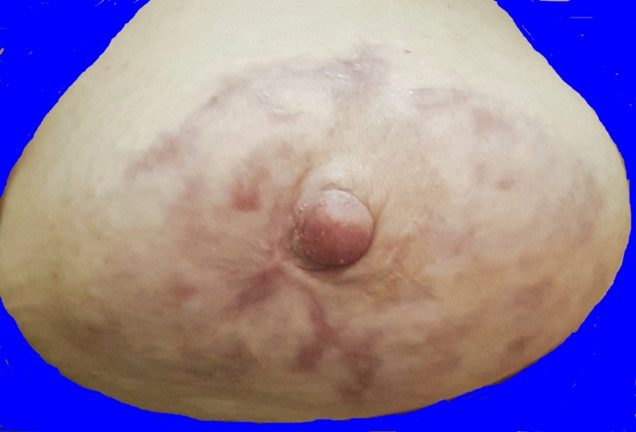 | 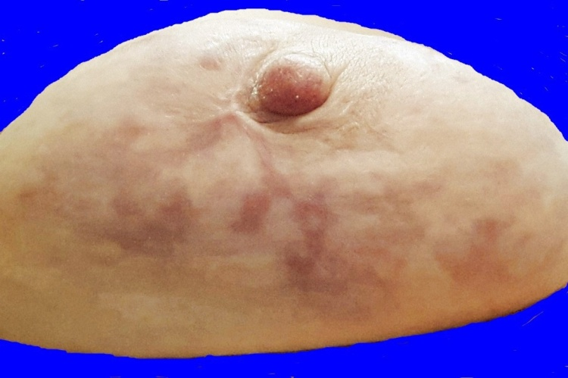
June 3, 19:01:30. Front view with major focus on the top part of the breast | June 3, 19:01:36. Front view with major focus on the lower part of the breast
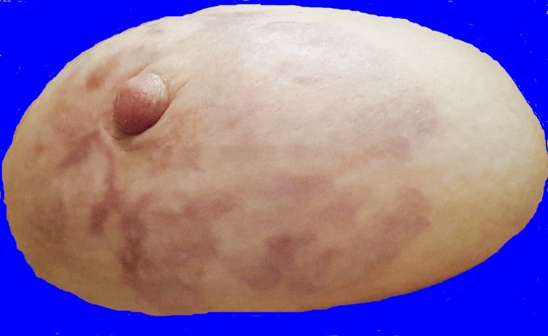 |  | 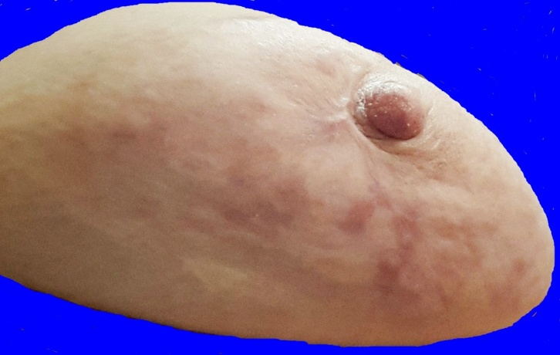
June 3, 19:01:45. Side view with focus on the side toward the other breast |  | June 3, 19:01:55. Side view with focus on the side toward the arm

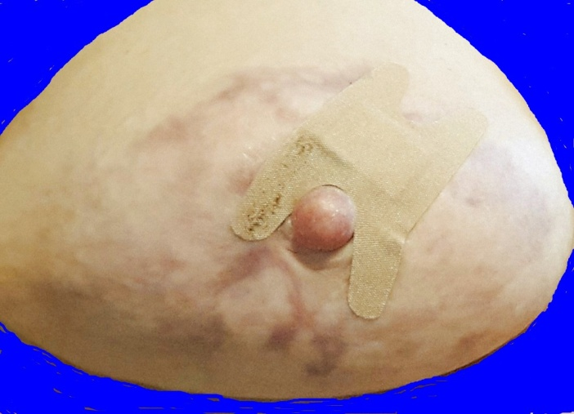 |  |  |  |  | 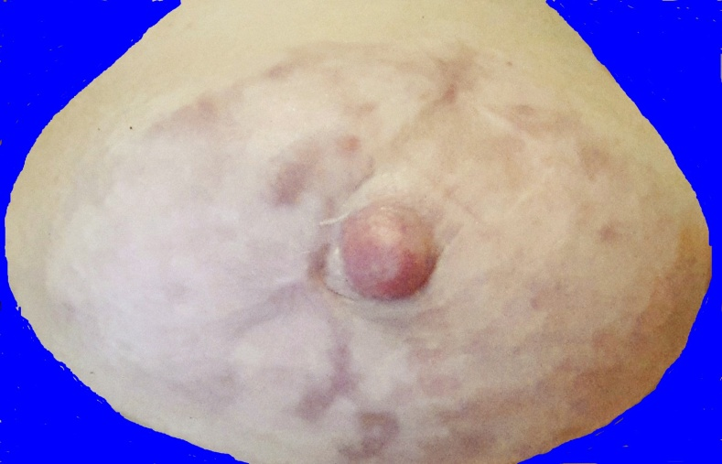
June 20, 13:01:14.  Salve applied and covered with band-aid. | June 21, 09:31:13. The salve has been washed off, and there is nothing but the rectangular imprint of the gauze part of the band-aid.
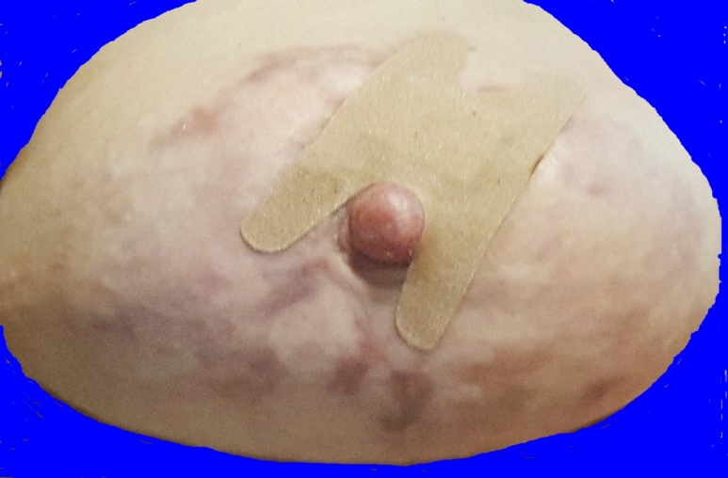 |  |  |  |  |  |  | 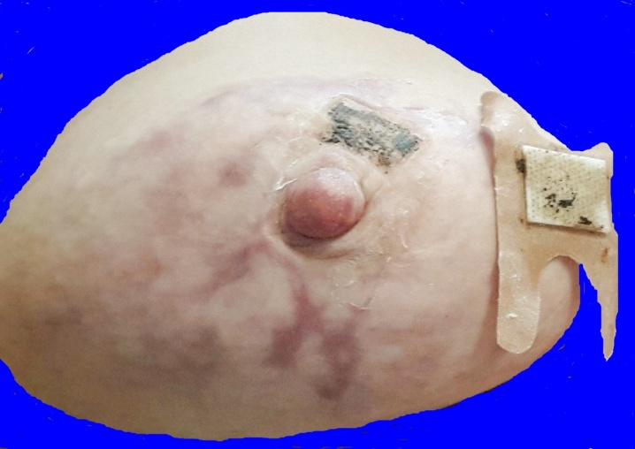
June 23, 14:23:54. Here is where the band-aid is this time. |  |  |  |  |  |  | June 25, 14:26:26. As the band-aid is pulled off, you can see the rectangle of salve.
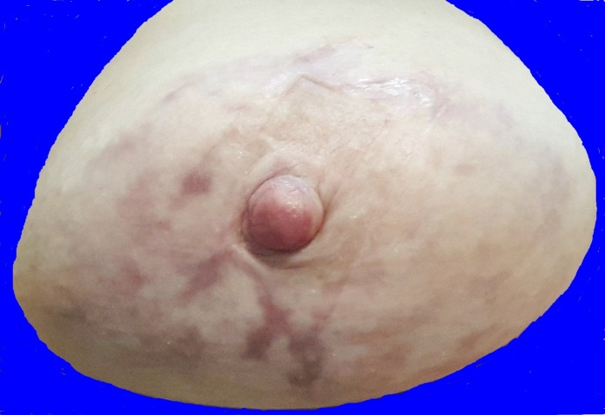 |  |  |  |  | 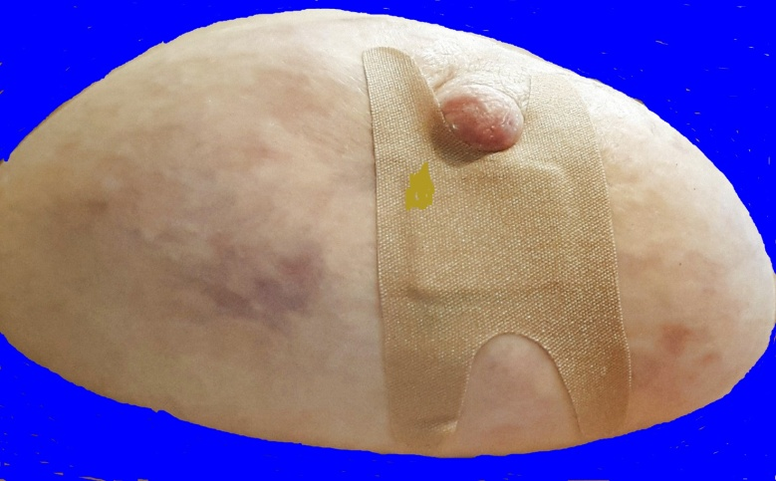
June 25, 14:27:21. The salve has been washed off, and there is nothing there except the rectangular imprint of the gauze on the band-aid. |  |  |  |  |  |  |  |  |  | July 1, 12:51:32. A new application of salve.
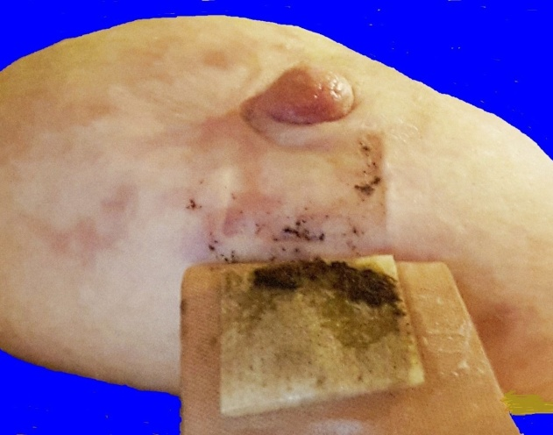 |  | 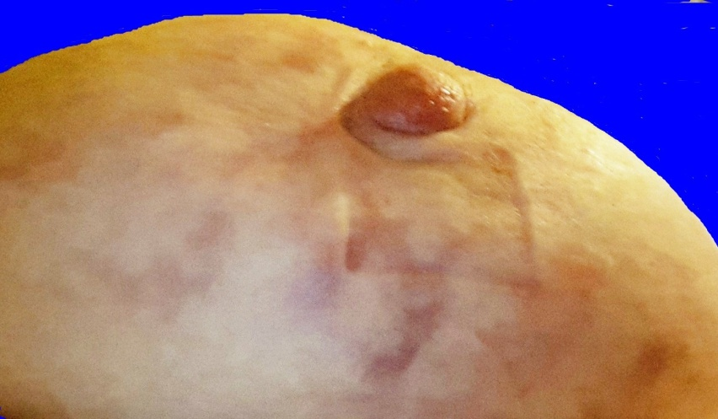
July 2, 11:19:11. The salve and the band-aid over it come off. |  | July 2, 11:20:35. Again there is nothing there but the slight imprint of the rectangle of gauze.
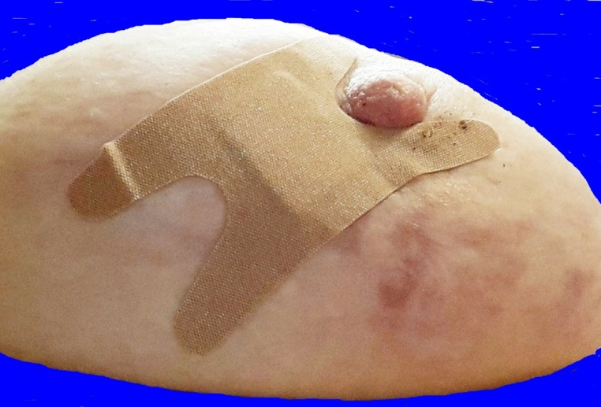 |  |  |  |  |  |  | 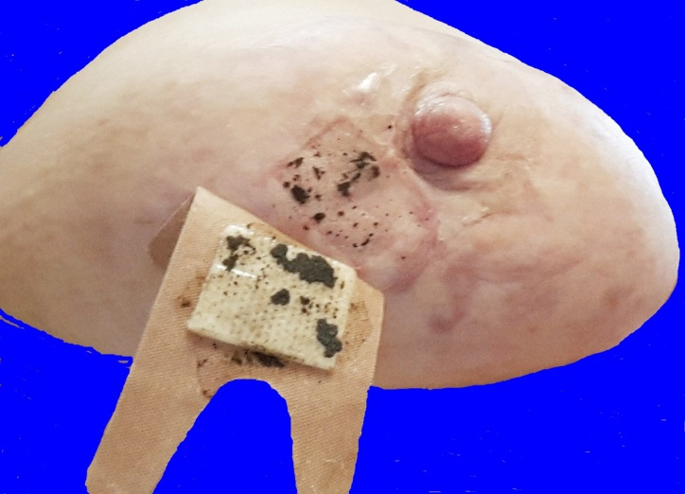
July 3, 09:04:46. Another application of salve. |  |  |  |  |  |  | July 4, 11:23:54. The band-aid comes off. This is more than 26 hours later.
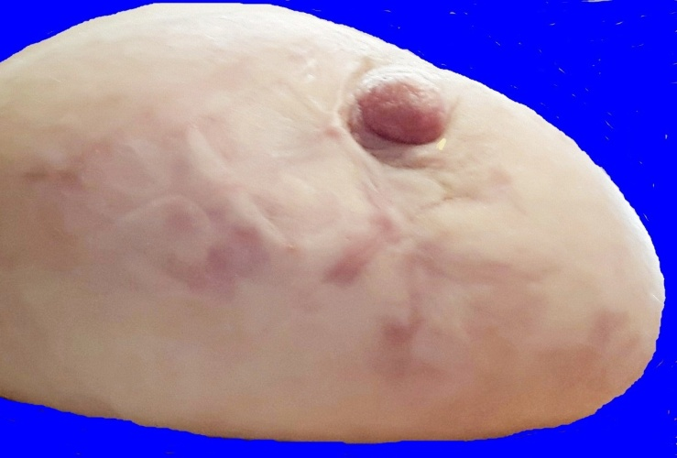 |  |  |  |  |  | 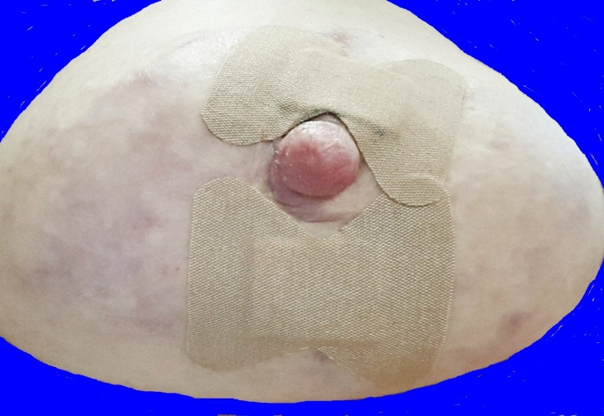
July 4, 11:24:49. Again, there is nothing but the rectangular imprint of the gauze on the band-aid. |  |  |  |  |  |  | July 16, 11:59:16. Notice there are now two band-aids above with applications of salve.
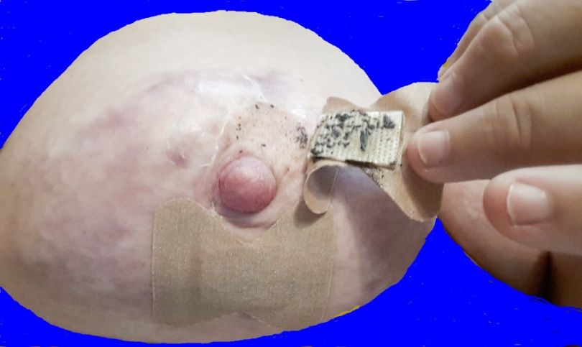 |  |  |  |  |  |  |  |  | 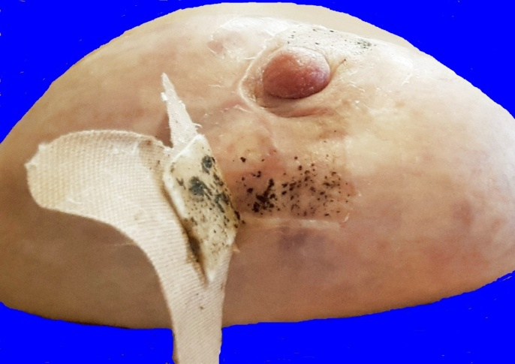
July 17, 11:53:44. The first band-aid comes off. |  |  |  |  |  |  |  | July 17, 11:54:24. The second one comes off.
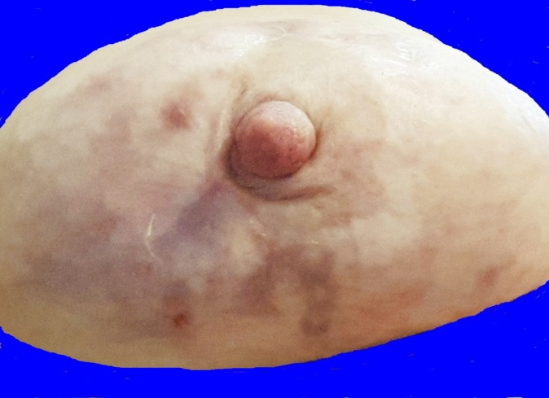 |  |  | 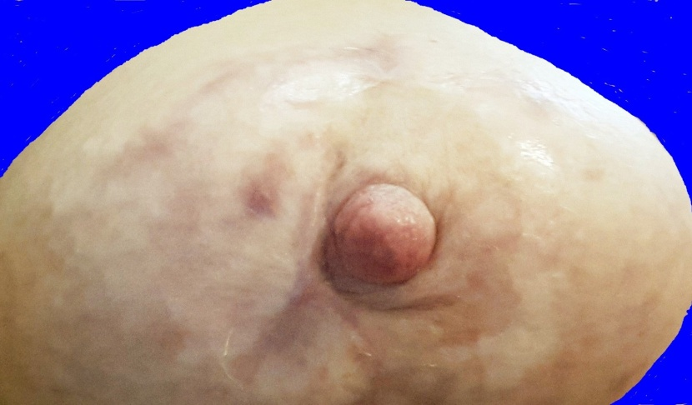
July 17, 12:01:07. This picture has more fo-cus on the lower part of the breast. There is nothing there as far as escharotic reaction. The dark spot of hyperpigmentation to the left of the nipple is where the bottom part of the question mark-shape eschar was attached. |  |  |  | July 17, 12:01:24. This picture has more focus on the upper part of the breast. Once again, there is nothing there except increasingly large areas where the skin is returning to its normal color. The remaining scar tissue and hyperpigmentation should slowly continue to dissipate as time goes by.
Compare the pictures on the last several pages from June and July, 2015 to June of 2014, when escharotic reactions developed very quickly because there was a lot of cancer there. If cancer cells are below the surface of the skin,
the salve will go down inside in pursuit of them.

In June of 2015, the salve could not find any cancer cells to go after.
That is why no reaction occurred.

Eschars Are Temporary;

Mastectomy Is Permanent!

Appendix of Supporting Documents

On the next several pages are medical documents supporting the diagnosis of invasive ductal carcinoma of the right breast, and showing the patient’s progress in the battle to eradicate this condition. They include such things as the original diagnostic pathology report, follow-up pathology reports on the ejected eschars, laboratory reports, and radiology reports.

The original documents have been copied and saved, both in their original format, and in another format, contained herein, in which the patient’s name and the names of all doctors or other medical personnel have been redacted to protect personally identifiable information.

Nov. 4, 2013. Diagnostic Pathology Report, Page 1

Nov. 4, 2013, Surgical Pathology Report
Nov. 6, 2013, Diagnostic Pathology Report, Page 2
January 29, 2014, Ultrasound Imaging Report
(The print below is so small that I have divided the page in half and reprinted it
in larger format in the next two pages so it will be more readable.)
January 29, 2014, first half of ultrasound imaging report, enlarged
Notice on the next page where it says, “Transcription ID: Powerscribe.”
The record above, dictated by the radiologist, is electronically transcribed,
and sometimes the machine cannot “understand” what word someone is saying,
so there are a few places where the words do not make sense in the context.
Use your best judgment to figure out what word should have been there.
January 29, 2014, second half of ultrasound imaging report, enlarged
This radiologist came out of his office to talk to me after the technician transmitted the scan information to his computer. The findings showed that my first tumor spot had grown larger, and there was another one right beside it, and a tiny new spot behind the nipple that he believed was probably the beginning of another tumor. I knew he was right that the first tumor spot was larger, but the spot beside it was still too small to be visible, and the one behind the nipple would not have been visible anyway. This was before I learned about salve for breast cancer treatment.
This radiologist, however, used tumor growth as an excuse to read the riot act to me in regard to natural treatments. He told me to
(1) immediately abandon all natural treatments,
(2) get a mammogram,
(3) go back to see the surgeon, and
(4) make an appointment with the oncologist.
He said that if I did not do these things that he told me to do, I was going to be VERY UNHAPPY with the results. His predictions were all wrong, and I am glad I did not listen to him.
January 30, 2014, Letter from Radiology Department
regarding breast imaging on January 29
I didn’t have a mammogram, but I received the above letter from the hospital radiology department regarding the results of my “mammogram.” The above is obviously a form letter used to report back to the patient and the doctor who ordered the breast imaging. In the heading and in the first paragraph, they use the term “breast imaging” but after that, they use the term “mammogram” or “mammography: FIVE times. This shows the bias of conventional medicine in favor of mammography for breast imaging, even though mammography has been shown through exhaustive studies to have little if any benefit.
I started to have a few little scraps of eschar material coming loose and falling off around the end of June or the beginning of July. I acquired a specimen jar on July 1, and after that, the scraps of anything that fell off went in the specimen jar. Volume 1 of the picture book shows at least the bigger eschars that ejected during that time. The jar full of specimens was turned in and traded for a new jar on July 29.
After I turned in the first jar of eschar specimens and got the second empty specimen jar,
with the exception of small scraps that may have been lost in the shower or the bathtub,
everything that fell off the surface, or came out from deeper inside from July 29 to August 26
was in this second specimen jar. (See the documentation in the picture book,
volume 1, for at least some of what was in this specimen jar.)
Nov. 26, 2014, MRI Report, page 1
(Caution: Do not form a conclusion about the MRI report
until you have read my comments after the third page of the report.)

Nov. 26, 2014, MRI Report, page 2

Nov. 26, 2014, MRI Report, page 3

Dec. 1, 2014, Patient’s Comments on the MRI Report
There is diffuse architectural distortion of the right breast including overall decreased size compared to the left and with associated retraction of the nipple areolar complex.

I completely agree with the radiologist’s description of what the right breast looks like, but we know that there were causative factors that the radiologist did not know about; that is, the history of eschars and the scar tissue from the eschars. The radiologist had no knowledge about the black salve treatment and its effects.

I agree that when both breasts fall forward, like through the holes in the MRI table, the left one falls fully forward, but the right one is like it has a string attached to the inside of the nipple, or beside the nipple, pulling it back. This was apparently originally caused by the tumors near the nipple because this condition existed quite a while before I started using salve (See picture book, page 1); however, this inversion continued after the use of salve, and the development and ejection of eschars, especially the large eschar on that side of the breast, which ejected on July 15, 2014 (See picture book, pages 14 & 15), so my presumption is that the inversion that remains beside the nipple must be caused by scar tissue.

I do not agree with him that the right breast is now a smaller size; it is just a different shape. It is pulled in more beside the nipple, and puffs out more on both sides instead of completely falling forward through the holes in the MRI table, like the other breast.

There is significant patient body motion during the exam which hinders evaluation for subtle detail.

I vehemently disagree with the radiologist about the “significant patient body motion during the exam.” During this kind of MRI, you lie on a table inside a tubular-shape enclosure, facing downward, and the part of the table below your rib cage is sharply elevated, causing immense pressure against the rib cage. There is a hole in each side of the table for your breasts to hang down so they can be imaged. I tried very hard to do nothing more than breathe for over an hour while I was in there, but there were times when the technician told me to move further forward because gradually, your body slides down the steep slope where the rib cage is elevated. The radiologist’s idea that there was “significant patient body motion” had to be no more than an unsupported presumption on his part because he could not understand what he was seeing. I was there for the exam, but he was not there, and he did not see what happened. All he did was come in later, and try to read the images, obviously trying to account for things he could not figure out.

Abnormal enhancement is seen deep to the nipple and extending throughout much of the central lateral right breast.

The area he is talking about here is where I have the biggest scars from the ejection of the first (and largest) eschar.

Based upon diffuse distortion of the right breast architecture, much of the enhancement is probably secondary to extensive malignancy.

In other words, he did not really see anything that proved malignancy. The “diffuse distortion” that he saw was scar tissue in many places around the breast due to healing after the ejection of eschars. At least he was careful enough to use the word, “probably,” because he did not really know what caused the “distortion of the right breast architecture.”

I can understand why he was confused. Prior to the imaging session, I did not present any written or verbal information about what I had been doing because I did not want the use of natural therapies to cause him to make a prejudicial judgment about the findings. Perhaps I should have disclosed to him what we know about the eschars being the reason for scar tissue as the cause of the “diffuse distortion” which he thought was “extensive malignancy.”

The epicenter of the primary malignancy is probably in the more central anterior right breast measuring at least 4 cm in AP diameter and at least 2.8 cm in transverse diameter.

What he is calling the “epicenter of the primary malignancy” is the exact area occupied earlier by the main eschar mass, which formed around the two little tumor spots near the nipple, and then it curved around both above and below the nipple. It extended in a wide swath out around that area. (Again, see pages 14 & 15 in the picture book.)

Intense nipple enhancement would support tumor invasion of this structure.

The “intense nipple enhancement” also supports black salve invasion and “botanical surgery” in an area very close to the nipple.

CHEST WALL: There is abnormal enhancing soft tissue in the anterior right chest wall abutting the pleural surface of the right lung and likely extending through portions of the pectoralis muscle consistent with chest wall invasion. A metastatic deposit to the anterior chest wall is a differential consideration.

The doctor who has examined me many times during my journey through cancer says that he does not think there is any evidence of any deposit or metastasis to the chest wall, and I have never had any mass (before or since then) of any kind that could be felt anywhere above the breast. In using the word “anterior,” (toward the head), the radiologist does not say how far, or exactly where. If what he was actually seeing was scar tissue, I think it would be in the area of the two eschars that were at the top of the breast because these spots do still have scar tissue. (See pages 21-30 of the picture book.)

In the final analysis (bottom of page 2 of the MRI report), the radiologist gave his “impression” as follows:
Extensive malignancy involving the right breast as detailed above. Gross patient body motion generates significant artifact, limiting anatomic evaluation and rendering CAD analysis nondiagnostic.

Again, his reference to “gross patient body motion” is completely invalid. I only moved when I could not breathe because of the steep incline of the part of the table that pressed upward against my rib cage, and when the technician told me several times to move forward because the incline under the rib cage makes the patient slide down in the chamber. Other than that, I tried to hold as still as possible for over an hour in that chamber. The only way the machine could have detected “gross patient body motion” would be if the technician let the machine run right after she told me to move forward.

He admits that his anatomic evaluation was limited, and that the CAD analysis was rendered “NON-DIAGNOSTIC.” I disagree with his reason for drawing those conclusions (his presumption of gross patient body motion), but the bottom line is still that this MRI was “non-diagnostic.” He was used to seeing cancer patients who had been through surgery, chemo, and radiation, but scar tissue from eschar ejections would have been something that almost certainly was not part of his experience, so therefore, I suspect that he did not know how to interpret such results.

I think he should have put a comma here, but there is none in the original text.

